# **Chapter 2: ANALYSIS**

Analysis is the detail study of requirement for development purposes. It is the process of studying or examining something in an organized way to learn more about it.

Analysis is conducted for the purpose of studying a system or its parts in order to identify its objectives. It is a technique for solving problems that improves the system and ensures that all the components of the system work efficiently to accomplish their purpose.

# 2.1 Analysis Methodology:

It is the method of analyzing the performance of the system. There are numbers of methodologies which can be chosen according to the requirements and specifications. Some of them are:

1. Hard approach: - focus on standard structure
2. Soft approach: - focus on people views and opinions
3. Combined approach: - focus on both human and technical aspects

Hard approach is appropriate for this project. In this project, we’ve to focus more on technical aspects rather human views and opinion. We will be following standard structure, rules in development process. Also, it maintains the quality of the system. Appropriate for our kind pf organization is another reason of using it. Hard approach must be applicable for this project because of following reason:

* Focus on system need i.e. technical aspects
* Follow standard rules and regulation
* Easy to track down progress
* Maintain standard and quality

# 2.2 Feasibility Study:

Feasibility study is an evaluation of the practicality of a proposed plan. It analyzes whether the project is economically, technically, legally feasible or not. Its main aim is to detect all the possible issue, problems that could arise throughout development process. Feasibility study also allow business to address where and how it will deal with the problems and obstacles. It will also help to make strategy.

Different components of feasibility study that helps in project are:

1. Financial feasibility: - It is the prediction of money needed at first, how it will be using and the return from the investment. Software that we will use for the development process are open source such as SQL Server. These softwares are reliable, trustworthy, widely used and are developed by renowned company. Developing this system is financially possible according to the budget.
2. Technical feasibility: - This is the study of the currently available technical environment, gadgets, and software. Since we will be using open source softwares, good hardware and the system will be developed by well trained, qualified developer, there will not be any issue regarding to the technical aspects. Thus, the system is technically feasible.
3. Market feasibility: - To make the software/system successful we have to study current market scenario carefully. It studies the current market needs and ensure us that the system will fulfill the demands. This also helps us to analyze the similar product available in the market and makes sure that the system will able to compete with them.
4. Legal feasibility: - Our system must have to fulfill the legal criteria defined by the government. Also, it doesn’t contain any things that may affect other. This study finds out that our system will not break any rules and regulation. This help to study whether software will be legal or not. This system will contain only ethical things. Our study finds out that it doesn’t have any issues with the law.
5. Social feasibility: - System need to be accept easily by the users. It provides us the knowledge of what users want and like from the new software. It will help us to develop the software which society accept easily. Basically, this deals with the ethics. And in our case, we will do things which are ethical. This makes possible to develop system.

# 2.3 Requirement analysis:

Analyzing the user prospective for new or modified product is requirement analysis. Correct requirements should be identified to make the software successful. To find these, we need to focus on users’ demand, their problems with similar kinds of software. There is multiple way of requirement analysis. Some of them are:

1. Interview: - Face to face conversation with people is known as interview. This is more accurate and reliable technique of gathering requirement and information. This help to know the different views and opinions. This technique is more suitable if we have to consider people more than technical aspects. Accurate and reliable requirement gathering technique comes with more consume of time and money.
2. Questionnaires: - Questionnaires is the technique of gathering information from large number of people without talking face to face. It contains a set of questions and their possible answers and user just have to choose from them. This process is very fast, less money consuming but not much reliable and accurate. We can perform this technique if technical aspects are more important.

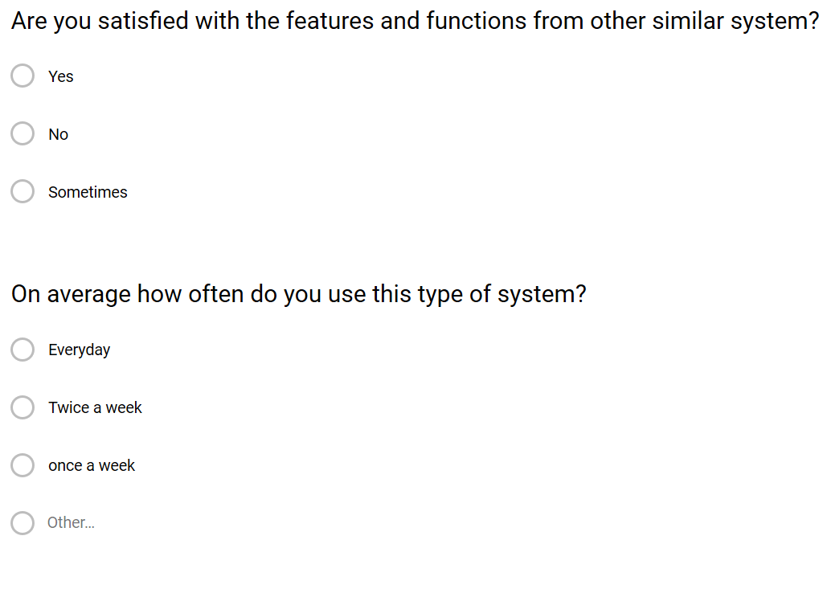

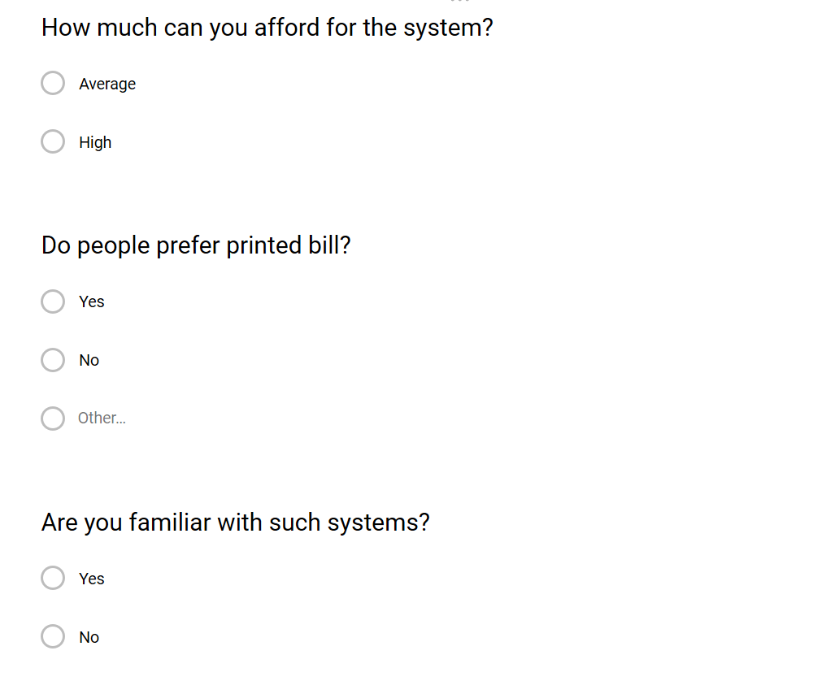

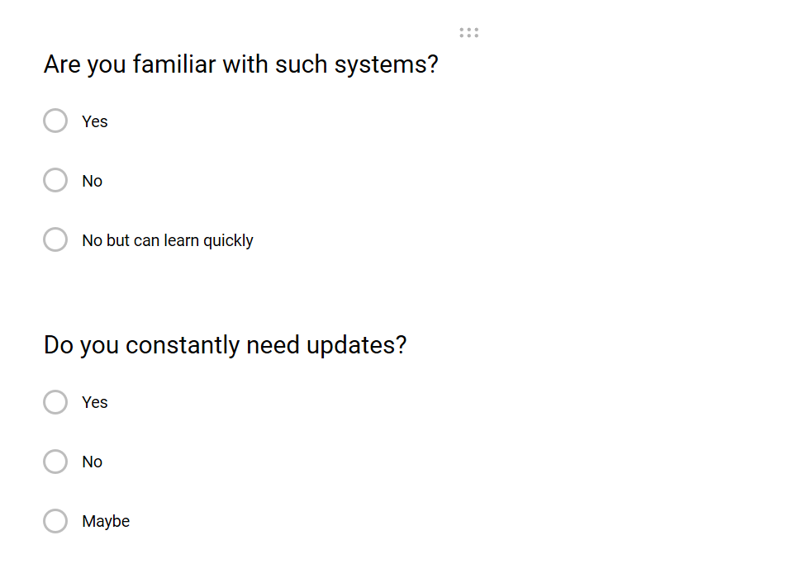

1. Observation: - Analyzing the user natural behavior of solving problems is observation. It helps us to determine the system features. It understands how user perform any task without using any automated system.

# 2.4 Software Requirement Specification (SRS):

**Functional specification:**

These are the functions or features that must or should be included in the software. This defines what the system is supposed to do. These are the functions which users use. These will be the most using features or functions of the software.

|  |  |  |  |  |
| --- | --- | --- | --- | --- |
| **ID** | **TITLE** | **DESCRIPTION** | **RATIONAL** | **DEPENDENCY** |
| FR1 | Registration | Admin, employee, users should able to register in the system | To complete login | FR1 |
| FR2 | Login | Admin, employee, users should able to login in the system | Access to features and functions of the system, to maintain security | FR1 |
| FR3 | Manage user | Update and delete option should be include in the system so that users can update and delete information such as profile, equipment, etc. | For system functionality and usability | FR1, FR2 |
| FR4 | Manage profile | Update and add admin | Updating profile | FR1, FR2 |
| FR5 | Manage table | Add, delete and update data | Record table | FR1, FR2 |
| FR6 | Manage dance types | Add, update and delete dance types | Dance types record | FR1, FR2 |
| FR7 | Dance uniform management | Add, update and delete dancing uniforms | Uniform details | FR1, FR2 |
| FR8 | Booking details | Booking different kinds of facilities | Recording booking details | FR1, FR2 |
| FR9 | Ordering dancing materials | Order materials | Recording order details | FR2 |

**Non-functional specification:**

These are the functions or features that are not essential to user but must be included in the system. Bad behavior of non- functional specification may affect the functional specification. Imagine one have access to many accounts with same username and password. Some of them are:

1. Performance: Every task should be completed as fast as possible. Also, it should be able to generate accurate and reliable results.

Imagine what will happen if one user has to wait 10 minutes just to login. It will create a bad impression. Worst he will stop to use our software.

1. Security: One of the most important non-functional requirements is security. It should be included to maintain privacy, availability and integrity. Policies such as strong password should be included.

Think one can access to the system with any username and passwords. What will be its result?

1. Scalability: Business may increase in the future. So, we have to develop a software that have capacity to change in size according business growth. It should able to handle the increasing users and also doesn’t affect the performance.
2. Modifiability: This is the process of changing the software partially according to the requirements. We make changes the existing system rather than making new one. It makes the code re-usability which save the both time and cost without compromising performance.
3. Reliability: Maintenance should be done after certain period of time regularly. This helps us to gain the consistent performance i.e. speed and accuracy. This will help to gain trust and believe of the clients.
4. Availability: User should able to access to their data without any problems. These data should be accurate, useful and right.

**MoSCoW prioritization:**

It is the prioritization technique for managing requirements. It is the common agreement between stakeholder and developing parties.

MoSCoW stands for:

M: Must have => must include in the software; insecure, incomplete without it

S: Should have => essential but not necessary in that time

C: Could have => desirable but less required

W: Won’t have => not required

It states that we have to work on must have, should have and could have prioritization respectively.

|  |  |  |  |  |
| --- | --- | --- | --- | --- |
| **ID** | **REQUIREMENT** | **MoSCoW** | **RATIONAL** | **REMARKS** |
| 1 | Create account | Must have | Register user to use the system |  |
| 2 | Login system | Must have | Give access to the system |  |
| 3 | Manage details | Must have | Provide power to changes the details like username |  |
| 4 | Database | Must have | Store and retrieve data |  |
| 5 | Performance | Should have | Get accurate, reliable data in less time |  |
| 6 | Security | Must have | Maintain credential, integrity and privacy |  |
| 7 | Scalability | Should have | Help to change in size according to business |  |
| 8 | Modifiability | Could have | Save money, time by changing existing software partially |  |
| 9 | Reliability | Must have | Access to corresponding data easily |  |
| 10 | Availability | Must have | Data access |  |

**Hardware/software specification:**

Hardware and software play a vital role to run a software smoothly. Our proposed software needs suitable hardware to perform smoothly. They are essential to eachother to run smoothly. I’ve figured out some of them:

**Hardware specification:**

* Processor: Celeron 500MHZ or any PENTIUM Processor
* RAM: 2 GB minimum
* Hard disk: 50 GB minimum (SSD best)
* Display type: Standard VGA or SVGA card

**Software specification:**

* Operating system: windows/Linux
* Database: MySQL
* Platform: PHP
* Web server: XAMPP
* Web browser: Chrome, Brave
* Java Script

# 2.5 Use Case diagram:

This diagram is used to show how actor perform any function a goal. Actor are those who use the system simply human being. It consists the group of classes. It shows how the system will respond to the request from users’ point of view.

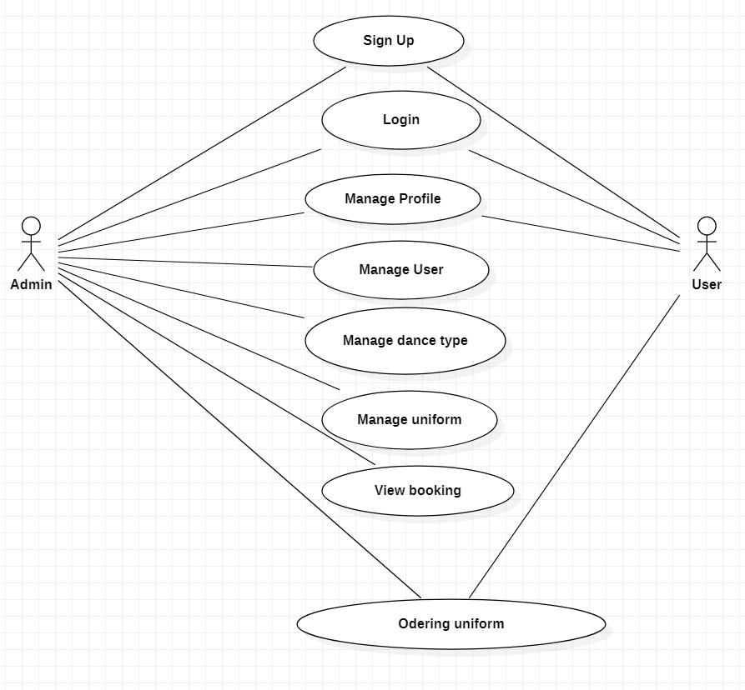

Figure 1: use-case diagram

**NLA:**

Natural language analysis is the process of identifying nouns, verbs and adjectives. Nouns relate to potential classes, verbs relate to potential object (function), adjectives relate potential attributes.

|  |  |  |
| --- | --- | --- |
| **Nouns (Classes)** | **Verbs (Function)** | **Adjectives (Attributes)** |
| Admin  User  Dance Types  Table | Login  Add  Remove  Delete  Update  Logout  View | Admin id  Admin Name  User id  User name  Table No |

# 2.6 Class Diagram:

We perform this technique to find out class, attribute and operation. This is the diagram that shows the class, their operation and their attributes and relationship between objects. In the table top compartment represent class, middle compartment represent attributes and lower compartment represents operation.

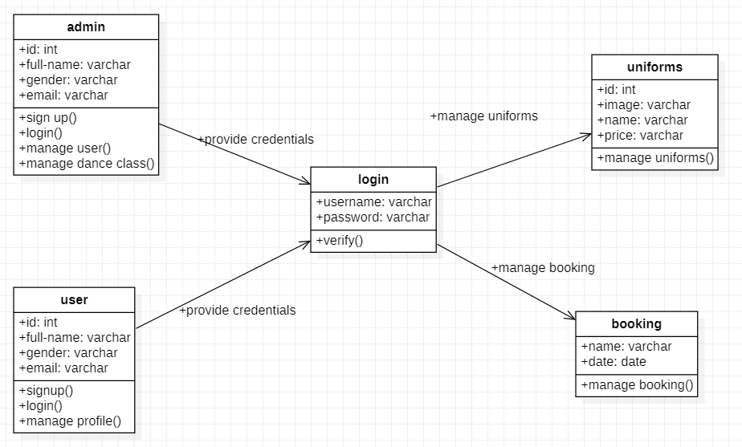

Figure 2: initial class diagram

# 2.7 System Architecture:

System architecture is conceptual design of a system that defines the structure, behavior and more views of the system. We will use three tier system architecture in this project. It is composed of three layers or tier of logical computing.

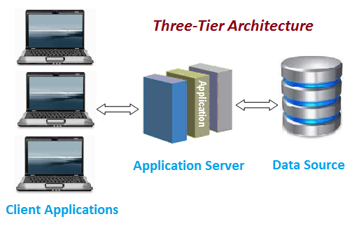

Figure 2: Three-Tier architecture

The tree tiers in three-tier architecture are:

1. **Presentation tier:** It is also known as first tier. This is the front-end layer and consist of the user interface. It translates the tasks and results to something the user can understand.
2. **Application tier:** It is also known as second tier. This layer coordinates the application, process commands, makes logical decisions and evaluation and perform calculations. It moves and process data between other two tier.
3. **Data tier:** It is also known as third tier. Here information is stored and retrieved from the database. The information is then passed back to the logic tier for processing and then eventually back to the user.

The reason behind using three-tier architecture are:

* Maintainability: - because each tier is independent of the other, updates or changes can be carried out without affecting the affecting the application as a whole.
* Scalability: - because ties are based on the deployment of layers, scaling out an application is reasonably straight forward.
* Flexibility: - because each tier can be managed or scaled independently.
* Availability: - application can exploit the modular architecture of enabling systems.
* Reusability: - components are reusable.
* Faster development: - because of division of work.

# **Chapter 3: DESIGN**

# Design:

Design is the plan or decorative pattern that show the functions, objects, methods of the software before it is developed. It provides the initial view of the proposed software such as how it will look, works.

Since I’m using object-oriented programming, this process helps me to divide the tasks into classes, how these classes will interact, what data each will contain and what action each will perform. It will make easier to understand the requirement easier and prevent redundancy. Risk will be very low if we use this process. It projects initial vision of the proposed software.

Types of software design level:

1. **Architectural Design:** It recognized the software as a system with multiple components associated with each other.
2. **High-level Design:** It focuses into how the system components can be implemented in forms of modules.
3. **Detailed Design:** It deals with the implementation of modules and the interactions between them.

# Structural Modelling:

Structural model projects the concept of the system and illustrate the relationship between system’s components. This model is independent of time.

# Final class diagram:

A class diagram is illustration of the architecture of a system which maps out the system’s classes, their attributes, methods and relationship between them. It provides the static view of the system which can be used as a blueprint for the final product.

**Justification of approach:**

* Forward and reverse engineering process.
* Analysis and design of the static view of a system.
* Provide basic notation for other modelling in UML.
* Construction of system using object-oriented programming (OOP)

**Notation used:**

|  |  |  |
| --- | --- | --- |
| **Notation** | **Explanation** | **Remarks** |
| + | This sign represents the class is public and is accessible within the namespace |  |
| - | This sign represents the class is private and is not accessible to other class |  |
| # | This sign represents the class is protected and only accessible within the solution inside a single namespace |  |
| Generalization | Generalization: -  This shows the inheritance from one class to another |  |
| Aggregation | Used to show relationship between class that have relation among their instances |  |
| Composition | Used to show the child class that is fully dependent to parent class |  |
|  | Used to show classes with attribute and function |  |



Figure 3: final class diagram

# Data flow diagram:

Data flow is used to show the flow of data in the system. DFD describes the process that are involved in a system to transfer data from the input to the file storage and reports generation.

**Justification of the approach:**

* logical information flow of the system
* determination of physical system construction requirements
* simplicity of the notation
* establishment of manual and automated system requirements

**Notation used:**

|  |  |  |
| --- | --- | --- |
| **Notation** | **Explanation** | **Remarks** |
| External entity | Represent human, system or subsystem. It is where data come from. |  |
| Process | It is function or activity where data is manipulated. |  |
| Data store | Data are store here. Simply, database |  |
| Data flow | Show the direction of flow of information. |  |

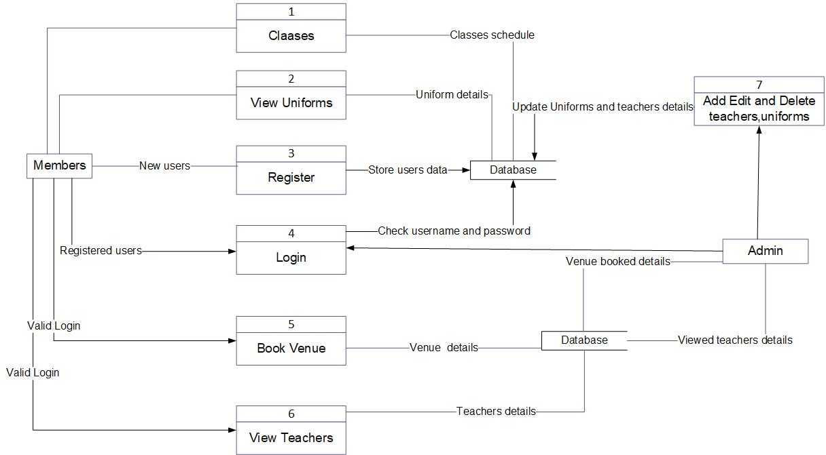

Figure 4: DFD

**DFD explanation:**

1. Admin provide login details
2. Login leads admin to admin panel
3. Admin can add/delete admin user and product
4. Member request to view the facilities and features
5. Product details are retrieved from database and display to customer
6. New users provide their details for registration
7. Details are store in database
8. Members provide details to login
9. System check the details with the database
10. Give access if details are valid otherwise deny
11. Details are checked with the details in the database
12. Give access and open home page if details are correct
13. Return back to login if details are wrong
14. Admin either manipulate customer or product details
15. Admin add/delete either customer or product
16. Products details are stored in database after manipulation

# Behavior Modelling:

It captures the varieties of interaction and instantaneous states within a model as it executes over time; tracking how the system will act in a real-world environment, and observing the effects of an operation or event, including its results.

# Activity diagram:

Activity diagram is graphical representation of flow of activity from one to another. This describe the dynamic aspect of the system. It is essentially an advanced version of flow chart that modeling the flow from one activity to another.

**Justification of approach:**

* Describe the sequence from one activity to another.
* Demonstrate the logic of an algorithm.
* Illustrate the various steps involved in a UML use case

**Notation used:**

|  |  |  |
| --- | --- | --- |
| **Notation** | **Explanation** | **Remarks** |
| Start | This symbol represents the start point of the system |  |
| Action/activity | This symbol represents the action or activity |  |
| Action flow | This symbol represents the flow of action from one to another |  |
| Decision | This shows where decision is made of the action |  |
| Merge |  |  |
| Join node | It joins the multiple activities into single activity |  |
| Fork node | This splits one activity into multiple activities |  |
| Swim lane |  |  |
| End point | This symbol represents the end point of the activity |  |

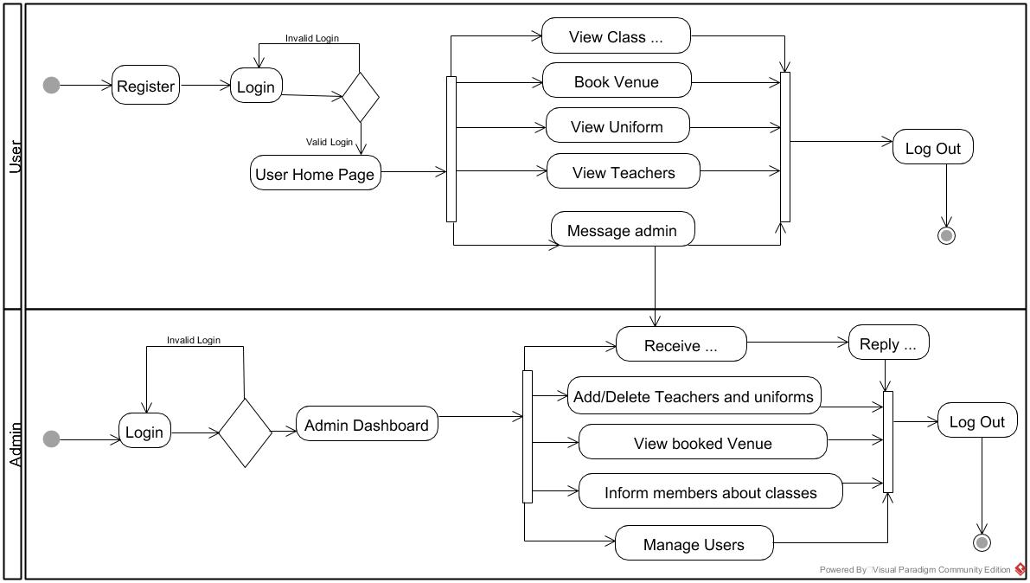

Figure 5: activity diagram for login

**Activity diagram explanation:**

1. Users provide login details to access the system
2. System check the details
3. If details are valid, dashboard is opened otherwise it moves back to login
4. User logout from the system
5. Admin make decision either to add, delete or update item and logout
6. User can make order and, manage classes and manage teachers

# Sequence diagram:

This diagram describes interaction of objects in sequential order. Sequence diagrams are time focus and they show the order of the interaction visually by using the vertical axis of the diagram to represent time what message are sent and when.

**Justification of approach:**

* Used to understand the detailed functionality of current or future systems
* Visualize how message and tasks move between objects in the system
* Analyze and visualize the logic behind function, operation or procedure

**Notation used:**

|  |  |  |
| --- | --- | --- |
| **Notation** | **Explanation** | **Remarks** |
| Lifeline | Used to represent the time duration. |  |
| Message | Used to share message between classes. |  |
| Reply message | Response to the message |  |
| Self-message | Process or method arise within the lifeline operation |  |
| Alternate | Used to show the choices |  |

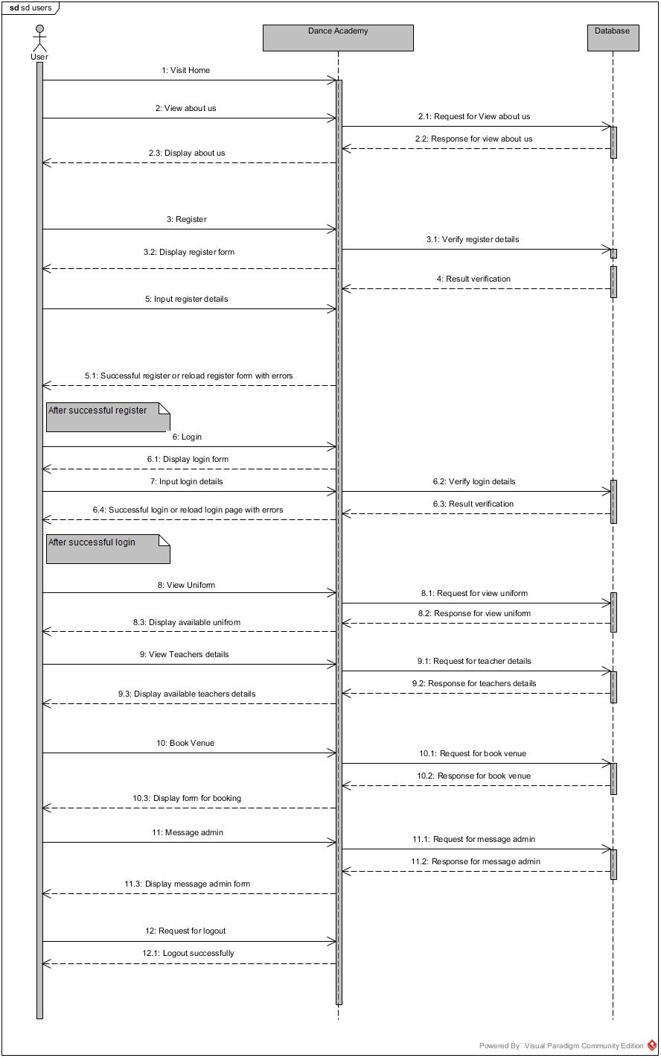

Figure 6: sequence diagram for user

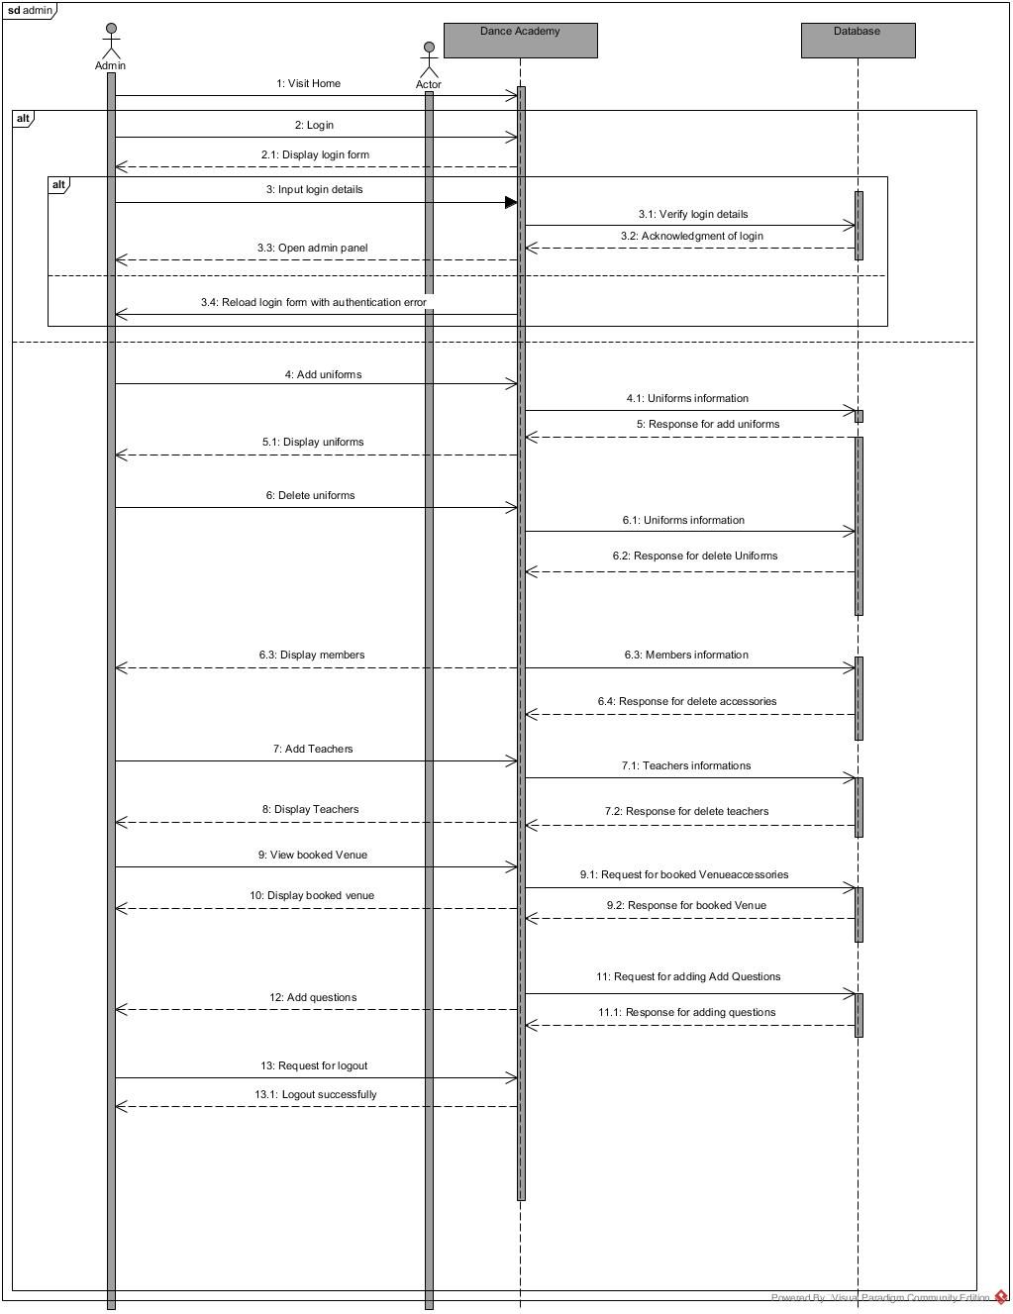

Figure 7: sequence diagram for admin

# Database Modelling:

Database is another important thing in system. Database modelling is the process of creating a database model for the data to be stored in it. Database modelling helps in the visual representation of data and enforces business rules, regulatory compliance.

# Data dictionary:

The table which contain the overall details of data that define the principle of database design and work. It contains database metadata. It describes things such as access to data, where the database is physically located.

**Column User**

|  |  |  |  |  |  |
| --- | --- | --- | --- | --- | --- |
| **Column Name** | **Type** | **Length** | **Nullable** | **Key** | **Constraint** |
| Id | Integer | 20 | - | Primary key | Pk_id |
| Full_name | Varchar | 100 | Null | - | - |
| Gender | Varchar | 100 | Null | - | - |
| Email | Varchar | 100 | Null | - | - |
| Phone | Varchar | 100 | Null | - | - |
| Dob | Varchar | 100 | Null | - | - |
| Username | Varchar | 100 | Null | - | - |
| Password | Varchar | 100 | Null | - | - |
| Re-password | Varchar | 100 | Null | - | - |

**Column Admin**

|  |  |  |  |  |  |
| --- | --- | --- | --- | --- | --- |
| **Column name** | **Type** | **Length** | **Nullable** | **Key** | **Constraint** |
| Id | Integer | 20 | - | Primary key | Pk_id |
| Image | Varchar | 200 | Null | - | - |
| Name | Varchar | 200 | Null | - | - |
| Gender | Varchar | 200 | Null | - | - |
| Email | Varchar | 200 | Null | - | - |
| Phone | Varchar | 200 | Null | - | - |
| Dance_style | Varchar | 200 | Null | - | - |
| Description_of_dance_style | Varchar | 200 | Null | - | - |
| Time | Varchar | 200 | Null | - | - |

**Column Uniform**

|  |  |  |  |  |  |
| --- | --- | --- | --- | --- | --- |
| **Column Name** | **Type** | **Length** | **Nullable** | **Key** | **Constraint** |
| Id | Integer | 20 | - | Primary key | Pk_id |
| Image | Varchar | 100 | Null | - | - |
| Name | Varchar | 100 | Null | - | - |
| Dance_style | Varchar | 100 | Null | - | - |
| Gender | Varchar | 100 | Null | - | - |
| Price | Varchar | 100 | Null | - | - |

**Column Booking**

|  |  |  |  |  |  |
| --- | --- | --- | --- | --- | --- |
| **Column Name** | **Type** | **Length** | **Nullable** | **Key** | **Constraint** |
| Name | Varchar | 100 | - | Primary key | Pk_name |
| Venue | Varchar | 100 | Null | - | - |
| Date | Varchar | 100 | Null | - | - |
| Size | Varchar | 100 | Null | - | - |

# ER diagram:

This diagram project the relationship between main entities of the system by mapping out the attributes, methods of the entities. It is used in database designing. ER model is based on the notation of real- world entities and the relationship between them.

It is used due to follow reason:

* Helps to define terms related to ER modeling
* Helps to describe entities, attributes, relationships
* Database designer gains better understanding of the information to be contained in the database.

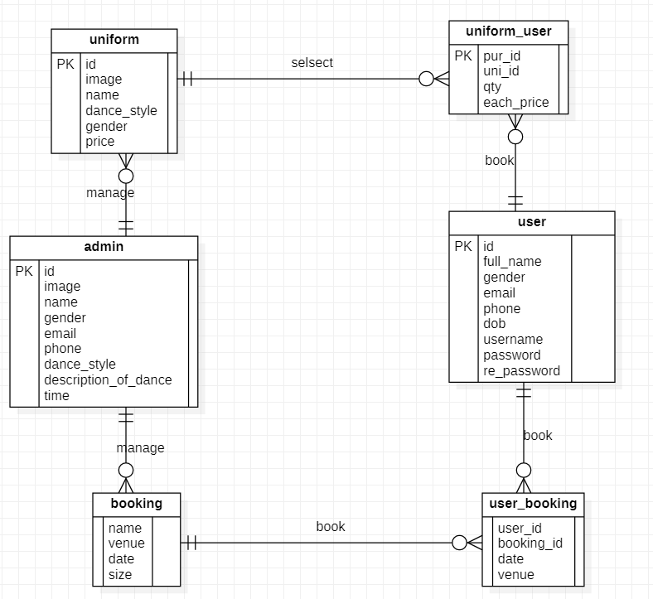

Figure 8: ER diagram

# User Interface Modelling:

This model illustrates the way how human react with the computer or system to perform any task in the system. It focused in looks or style.

Great UI have:

* Common icon and well leveled
* Simple and clear interface

# Prototyping:

This is the representation of how the system will look after its completion. This makes easy in coding.

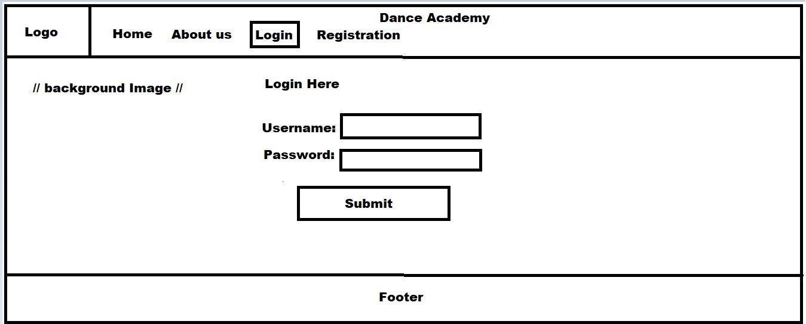**Login Prototype**

Figure 9: login UI

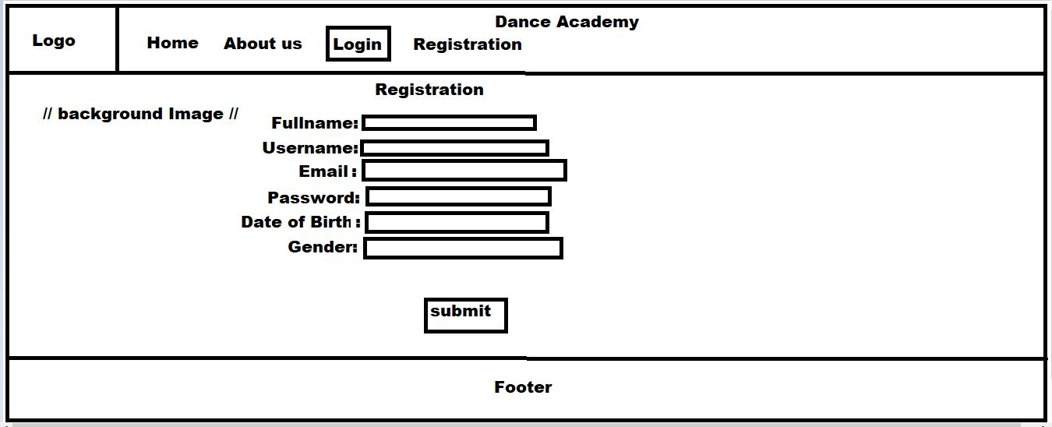**Registration Prototype**

Figure 10: registration UI

**About us Prototype**

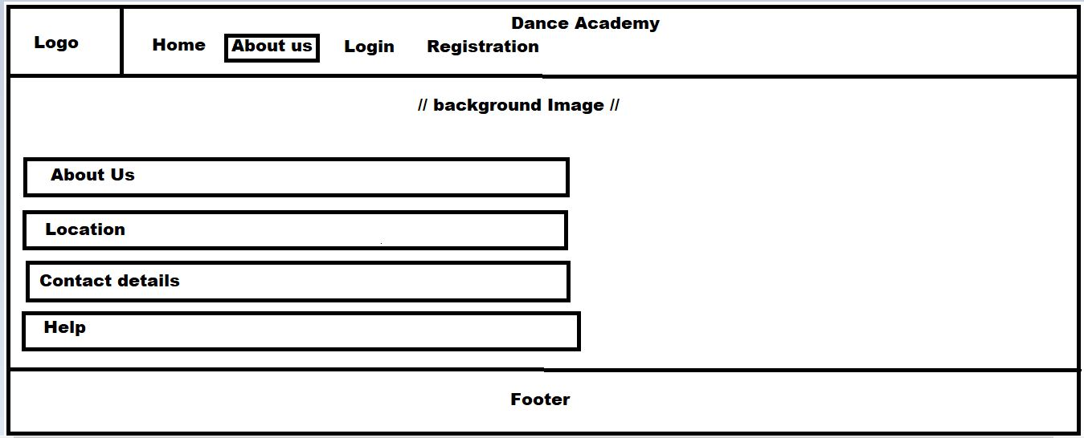

Figure 11: about us UI

# **Chapter 4: IMPLEMENTATION**

The process of putting a design into actual project is called implementation. It is the process of putting a decision or plan into effect or execution. In this part of the development, I had code to develop the actual software. This task is done in the third phase of the SDLC. It translates the design from the second phase to the actual working software.

**PROGRAMMING LANGUAGE**

I choose PHP as my programming language to implement the system. It is also appropriate for database driven development. It provides many features that makes the development easy. Open source, scripting language is another reason behind using this language (PHP).

**FRAMEWORK**

For implementation, I had used MVC framework. It makes the development process easy and fast. Tt separate components into three i.e. Model, View and Controller and they each handle a specific task. The component of Model corresponds to all the logic related to data with which the user works. The component of View is used for the application’s entire UI logic. Controllers act as an interface between components of Model and View to process all business logic and incoming request, manipulate data using the Model component, and interact with Views to render the final output.

**DATABASE (BMS)**

I used MySQL as database to manage all the data related to the application. It is free and reliable for my system.

**TOOLS USED**

* Microsoft Windows 10
* Sublime text
* Apache server
* MySQL database
* XAMPP

# **Chapter 5: TESTING**

In this phase, we evaluate the functionalities of the system with the expected the specification and requirements. It ensures that the system includes all the features and function as per the requirements. Bugs were identified and removed in this process. This phase verifies whether the system was ready to use or not. This also check the functionality of the system.

Some of the technique to perform testing are:

* Black box testing – This type of testing is done to check the external mechanism i.e. functionality of the system. This is focused on the result i.e. output rather than internal mechanism. Validation is done to check the functionality of the system.
* White box testing – Internal mechanism of the system are checked in this type of testing. Verification is one of the tasks done in this testing.
* Unit testing – In this testing all the unit of the software are tested. Testing of whether all the individual units are working are not, are done in this phase. It helps to reuse the unit in another system. It will decrease the chance of system failure.
* Integration testing – Test are carried out in a group of units at once to produce an output.
* Regression testing – In this testing new components are added in the system. After that, system is checked whether the function and features are running or not.

To check the correctness of the built system, I performed two testing. Those are black box and unit testing.

Reason behind using black box testing are:

* Check the functionality of the system.
* Test are done from the view of end-users.
* Help to identify difference between requirements and final product.
* No need of technical knowledge i.e. programming.
* Test cases can be generated before development and after specification.

Problems of using black box testing:

* Have small test area i.e. test only small number of inputs.
* If specifications are not clear then designing test case are difficult.

Benefits of unit testing:

* Reuse of the codes are possible
* Easy to change and maintain codes.
* Better for rapid development
* Finding bugs are easier

Problems of using unit testing:

* Professional are required

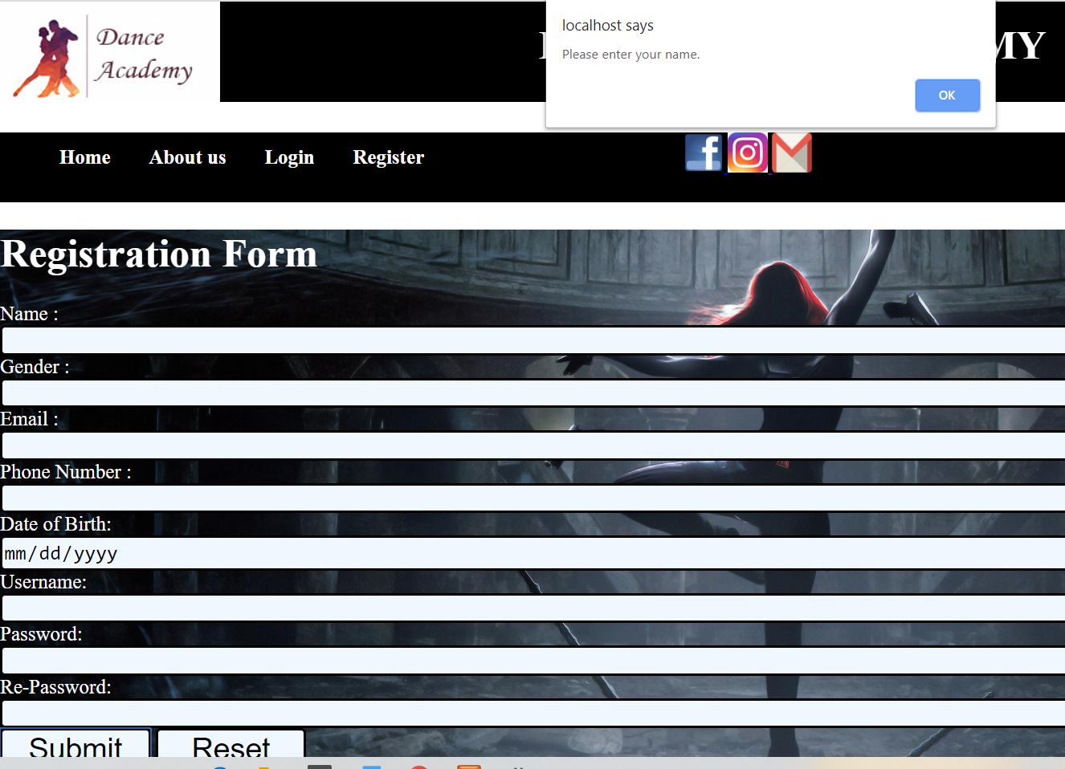

Figure 12: form validation

**Form validation**

|  |  |
| --- | --- |
| **Test ID** | 1 |
| **Test plan** | Check for validation in registration |
| **Expected Result** | Validation of form |
| **Actual Result** | Validate successfully |
| **Result** | Pass |

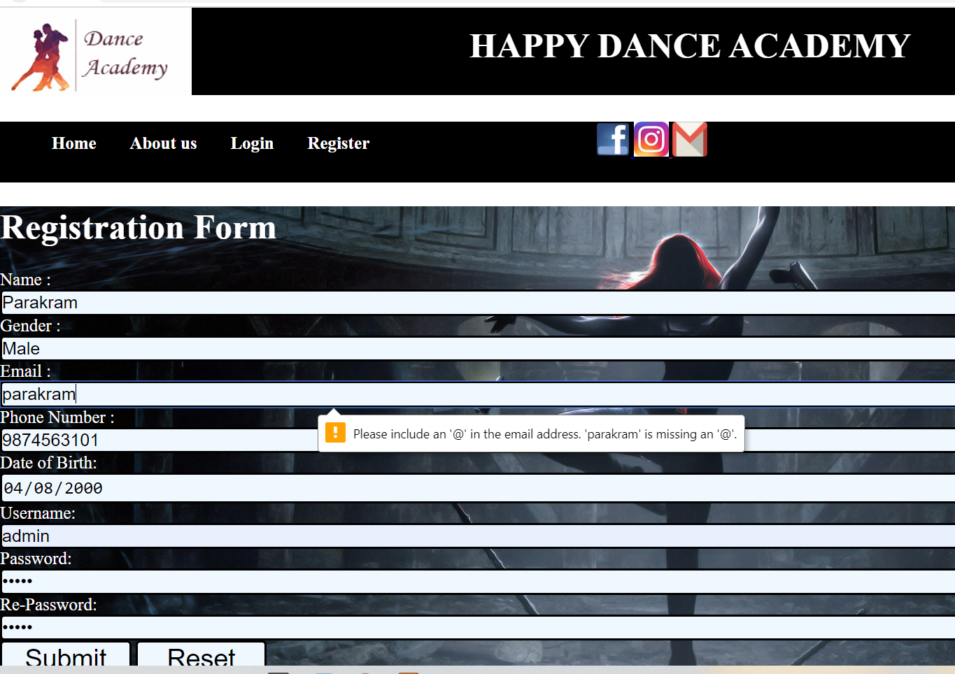

Figure 13: email validation

**Email validation**

|  |  |
| --- | --- |
| **Test ID** | 2 |
| **Test plan** | Check @ in email |
| **Expected Result** | Required @ in email |
| **Actual Result** | Validate successfully |
| **Result** | Pass |

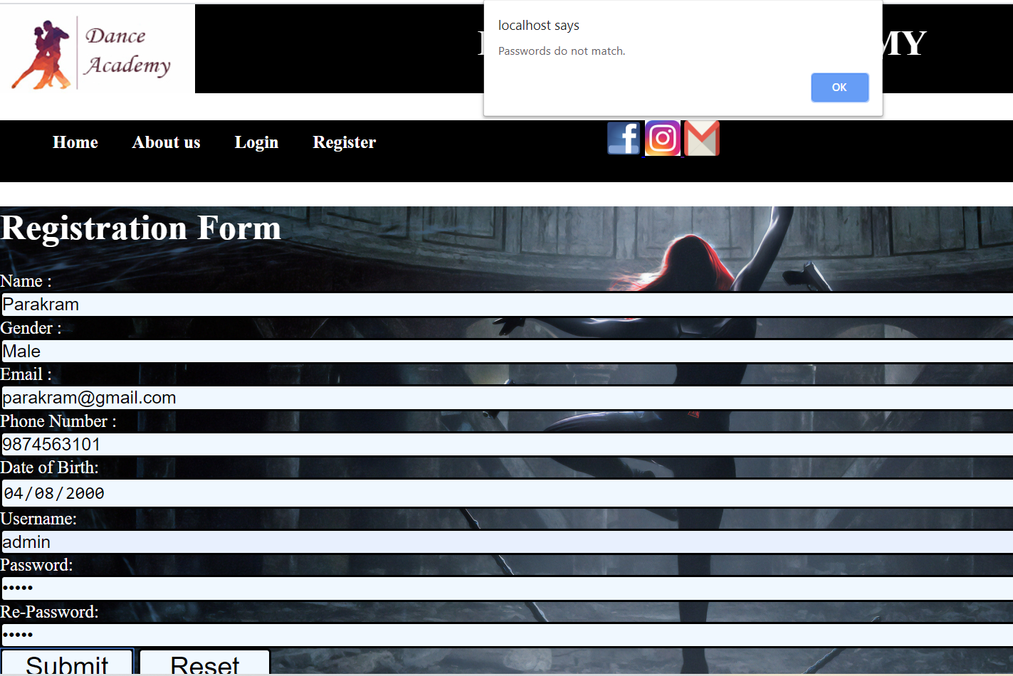

Figure 14: password match validation

**Password match validation**

|  |  |
| --- | --- |
| **Test ID** | 3 |
| **Test plan** | Check password and re-password |
| **Expected Result** | Required same password |
| **Actual Result** | Validate successfully |
| **Result** | Pass |

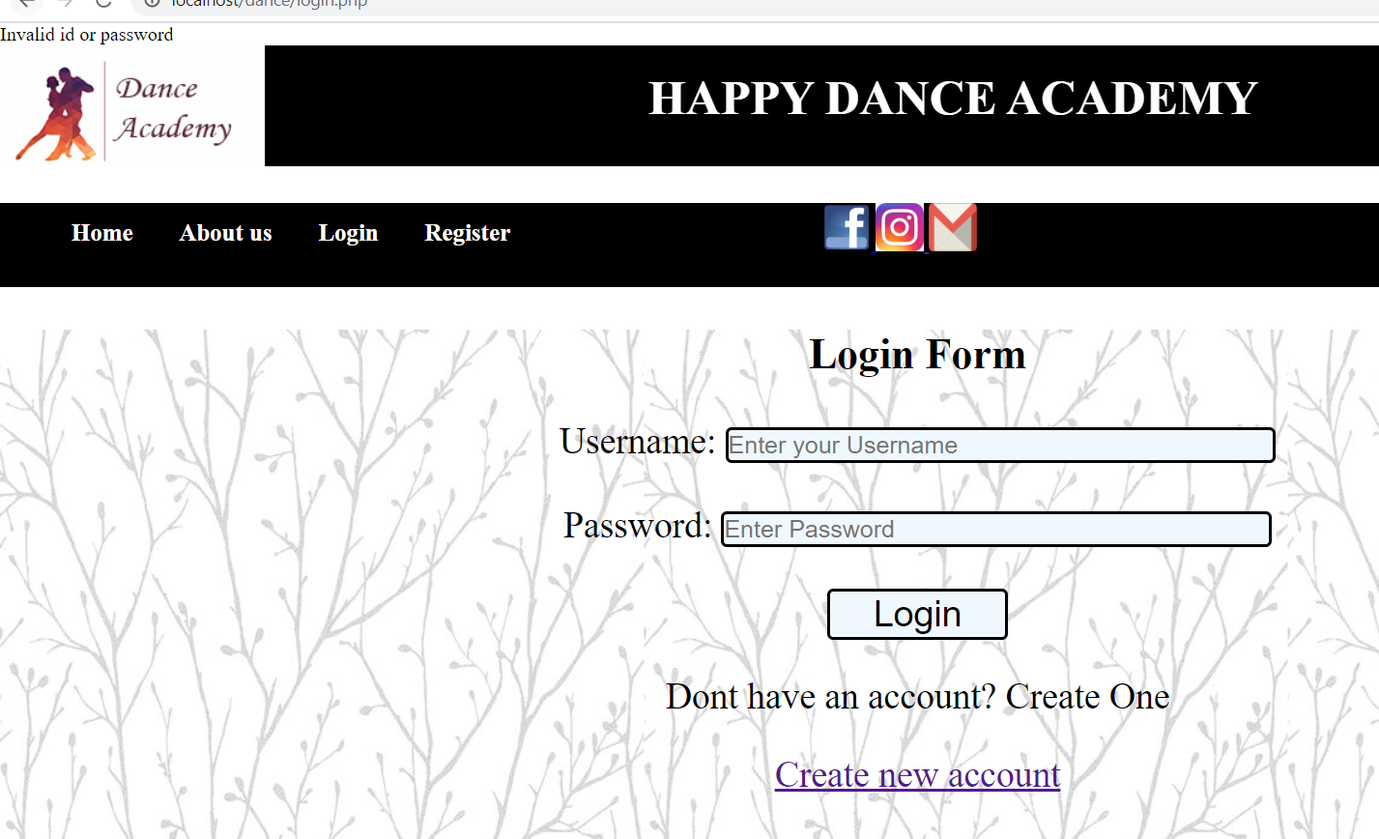

Figure 15: invalid username & password

**Username and password validation**

|  |  |
| --- | --- |
| **Test ID** | 4 |
| **Test plan** | Check username and password |
| **Expected Result** | Required valid username and password |
| **Actual Result** | Validate successfully |
| **Result** | Pass |

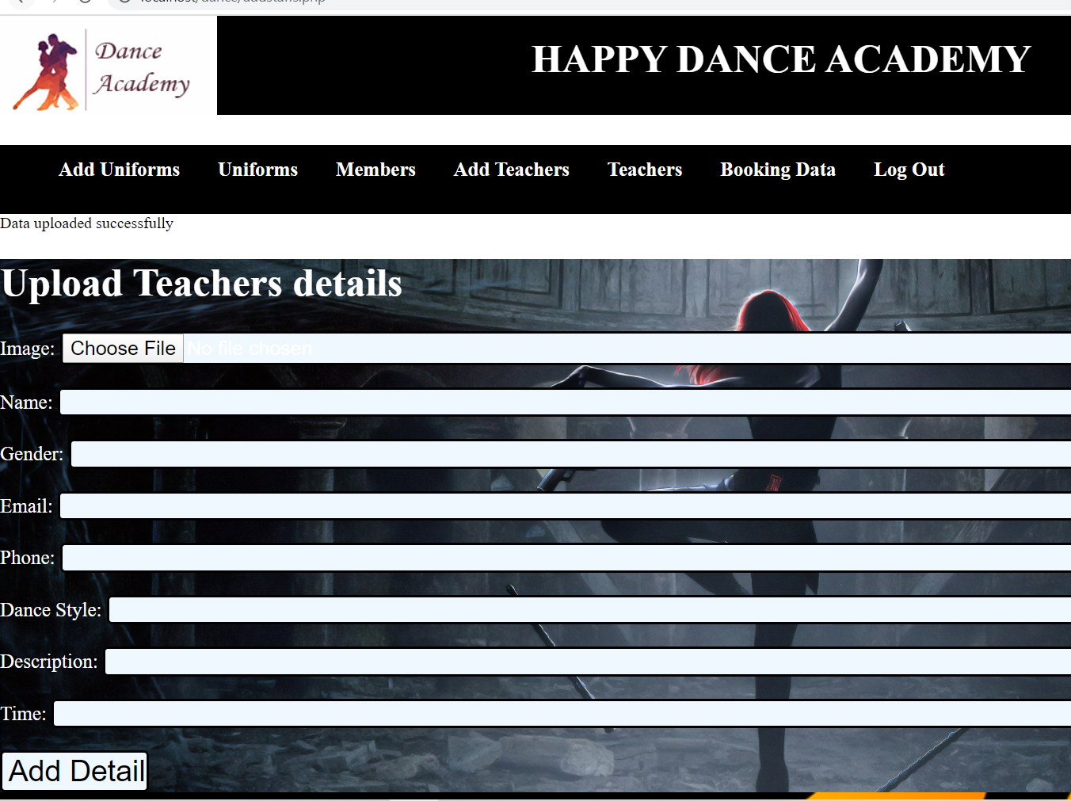

Figure 16: data save

**Data store**

|  |  |
| --- | --- |
| **Test ID** | 5 |
| **Test plan** | Check data store in database |
| **Expected Result** | Data enter in database |
| **Actual Result** | Validate successfully |
| **Result** | Pass |

# **Chapter 6: OTHER PROJECT ISSUES**

# 6.1 Problems and issues faced

The major problem that I faced during the development process was to identify and gather requirements. I had redesign some of the parts due to the functionality don’t match the requirements. Proper time management was another issue that arise during the period of development. Changing the design with the changes in requirements create some problems for me.

Limitation of project

* Not mobile friendly
* Minimum security
* Cannot handle large data

# Future works:

* Conversation between members
* E-pay

# **CONCLUSION:**

A web-based system for a dance academy was developed. For this, I had done various task. I performed analysis, design, coding, risk management, time management, etc. I choose PHP as my programming language. I took the help of software such as sublime test, XAMPP, etc. to develop this software.

We perform an analysis for this project. We use hard approach as analysis methodology. We perform feasibility study and find out the factors that may arise during development and how we will overcome them. MoSCoW prioritization is carried out to prioritized and manage the requirement. Use case and class diagram are created to show the relationship between user and system and between objectives respectively. NLA makes our job to find out the class, function and attributes. Also, we described hardware/software requirements to run the system. We follow the three-tier architecture.

Hence, a functional website for the Happy Dance Academy was developed successfully. It has the features like registration, login, add teachers, etc. which will help to manage the academy smoothly and easily. Website was designed and developed in such a way that anyone can use is easily.

# Appendix

**Code structure**

**Index.php**

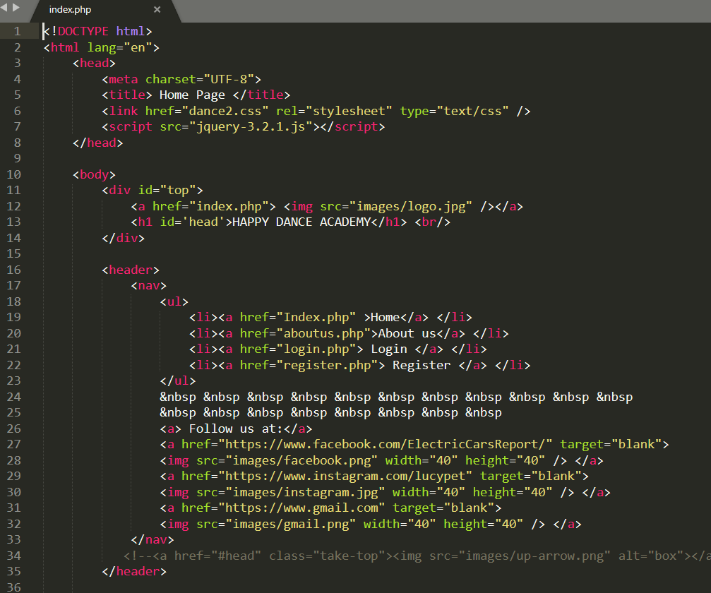

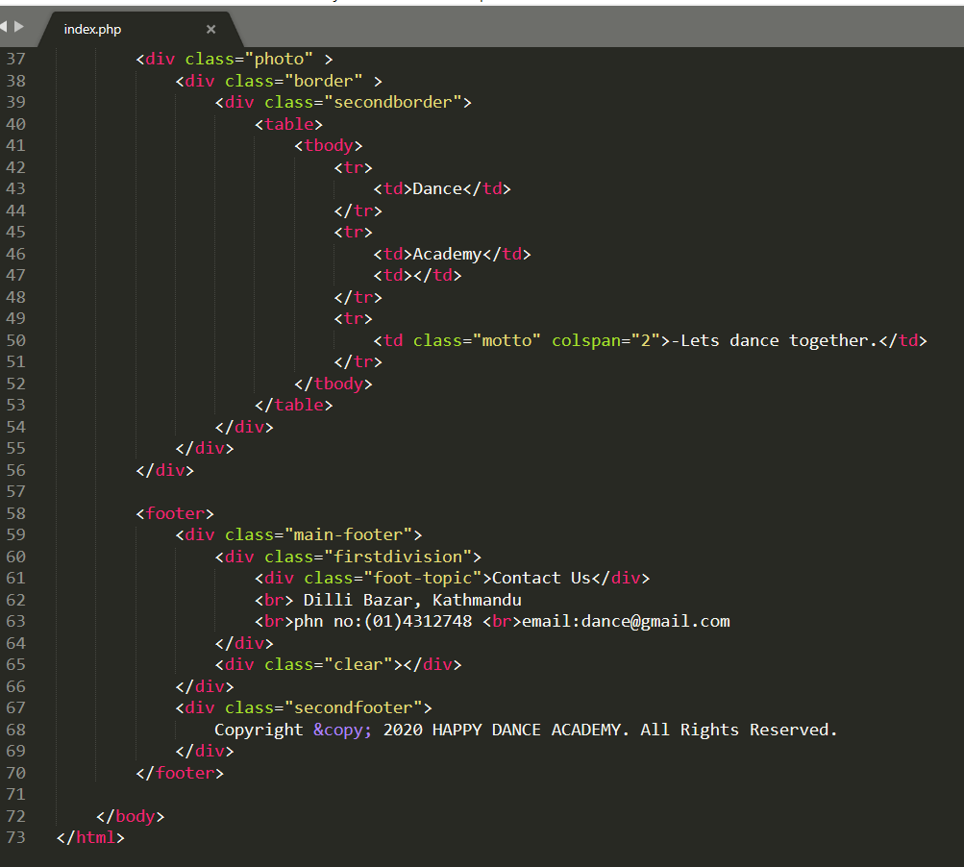

**Aboutus.php**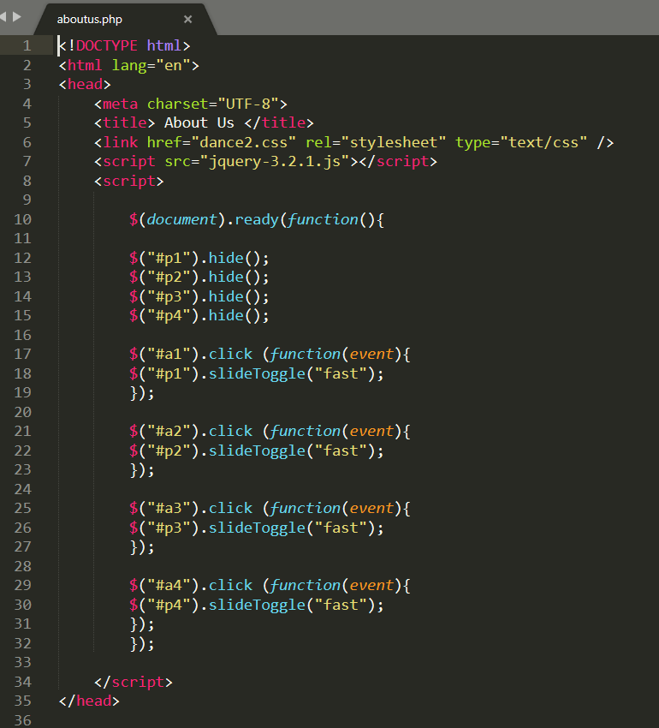

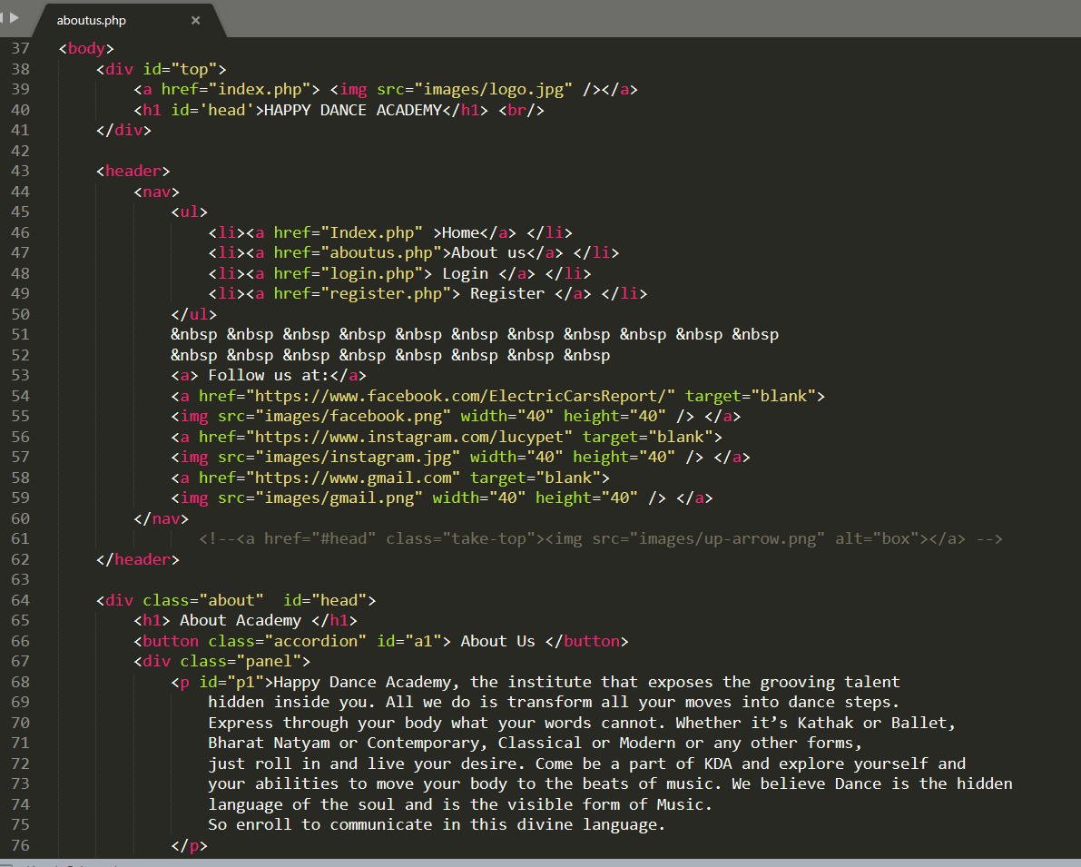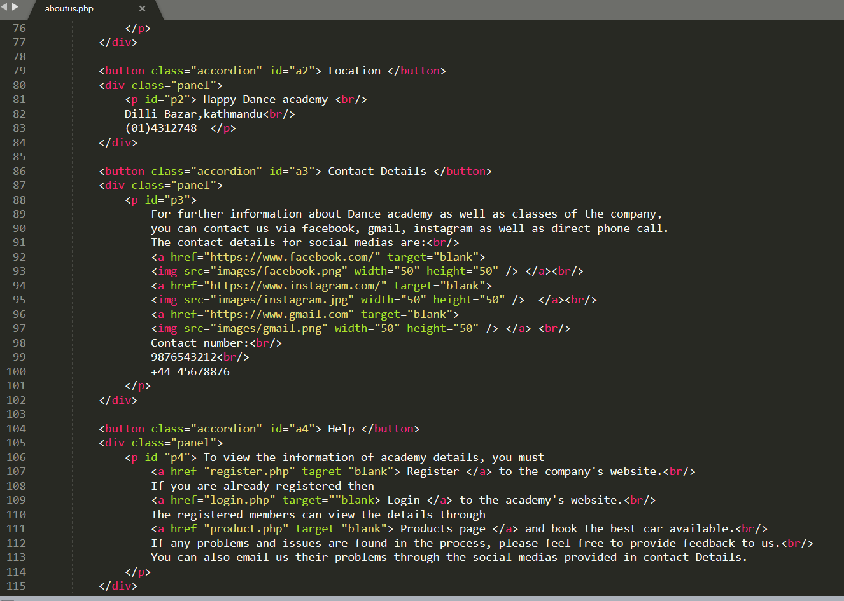

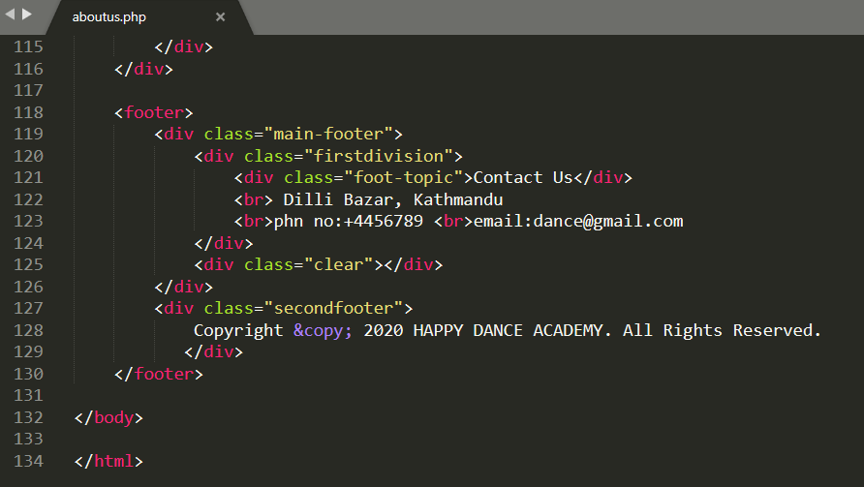

**Login.php**

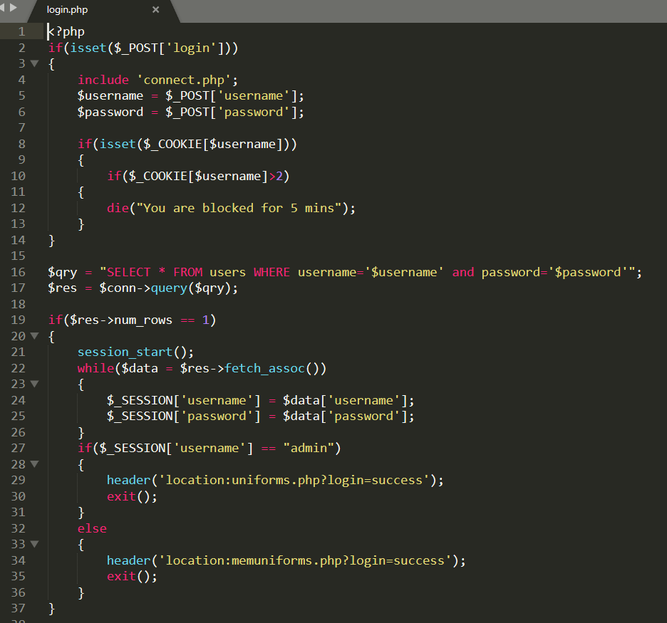

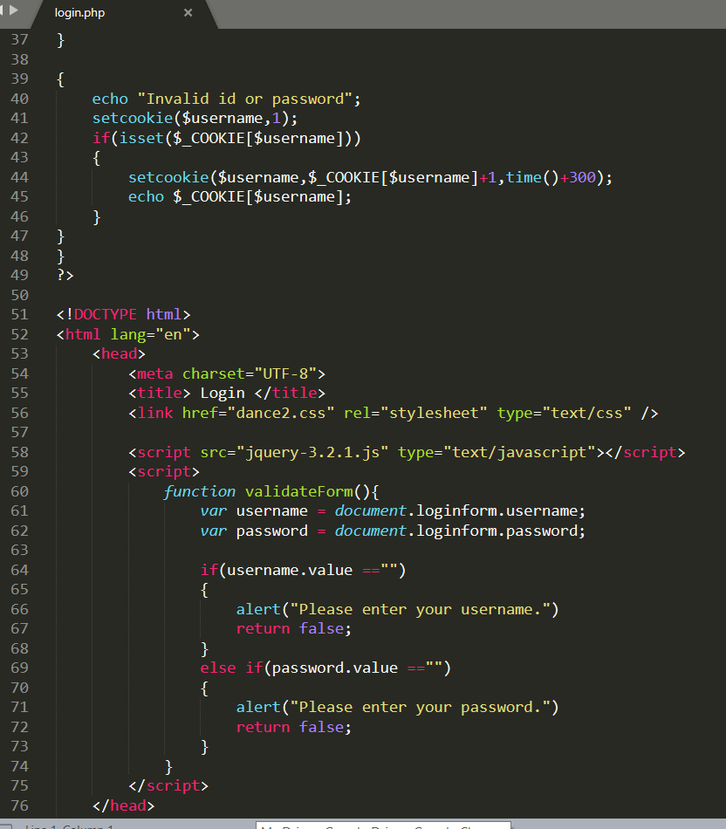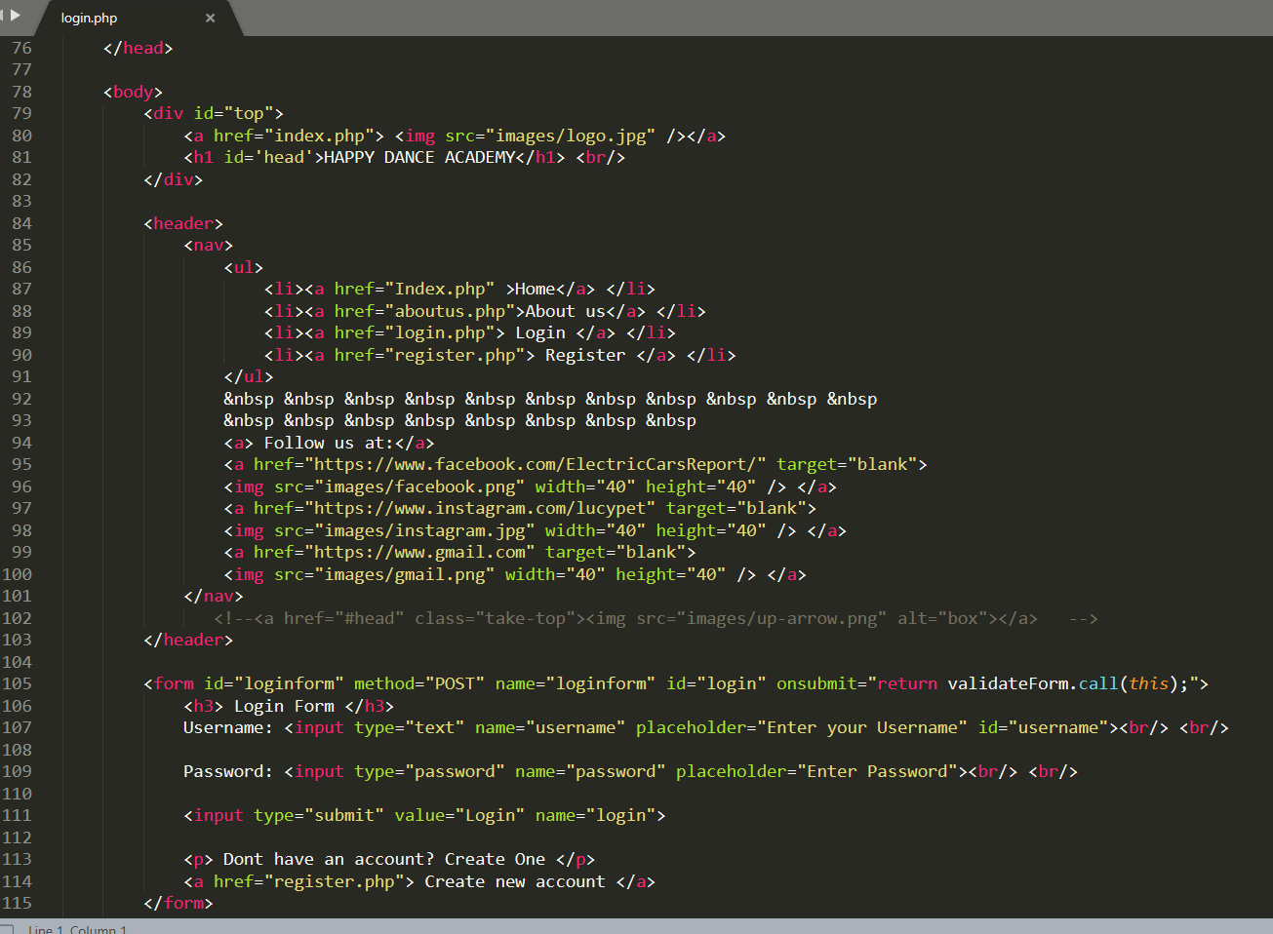

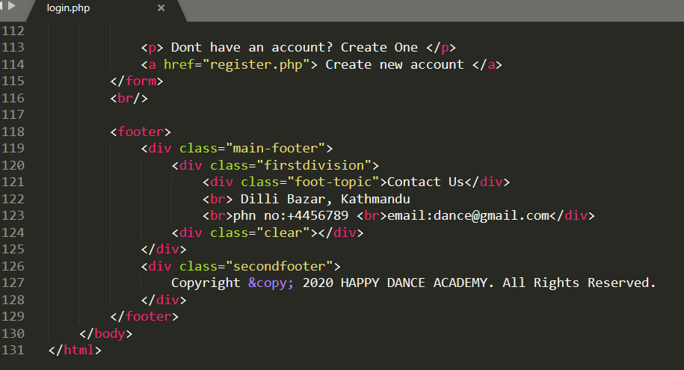

**Register.php**

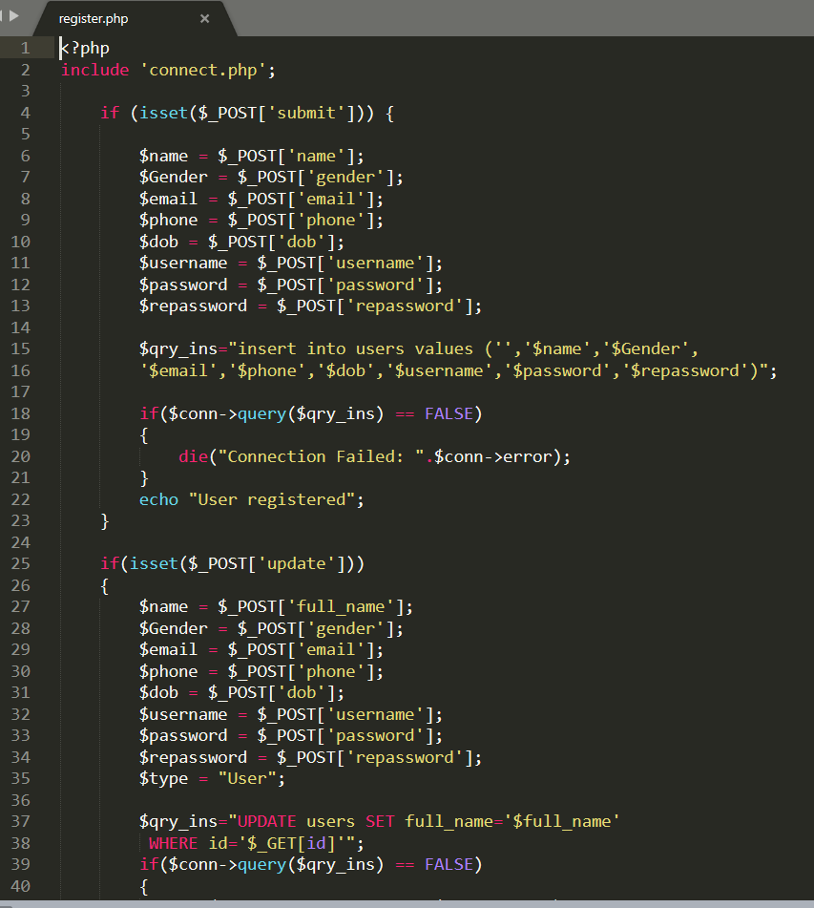

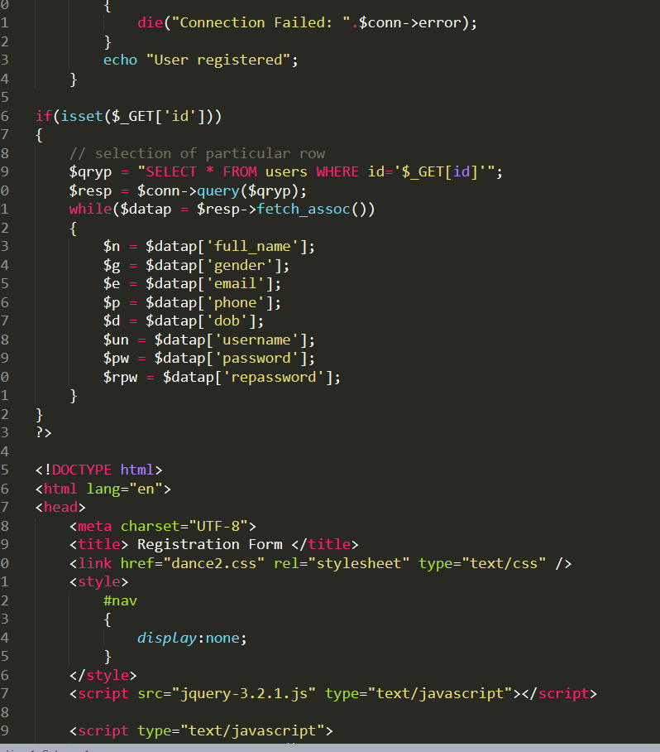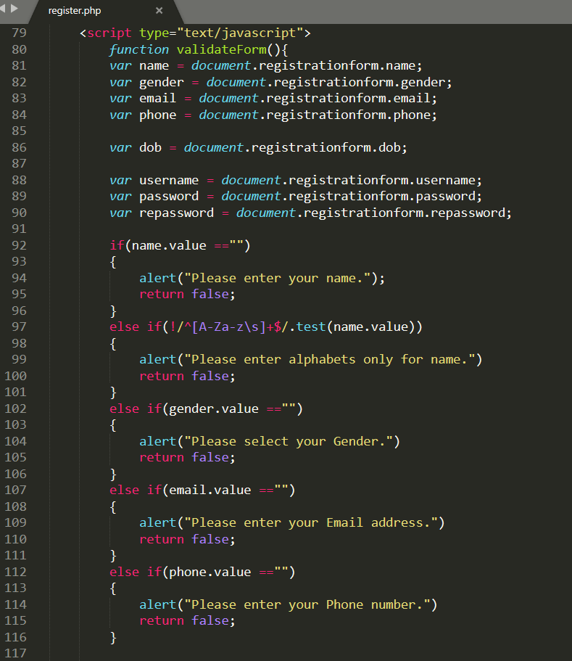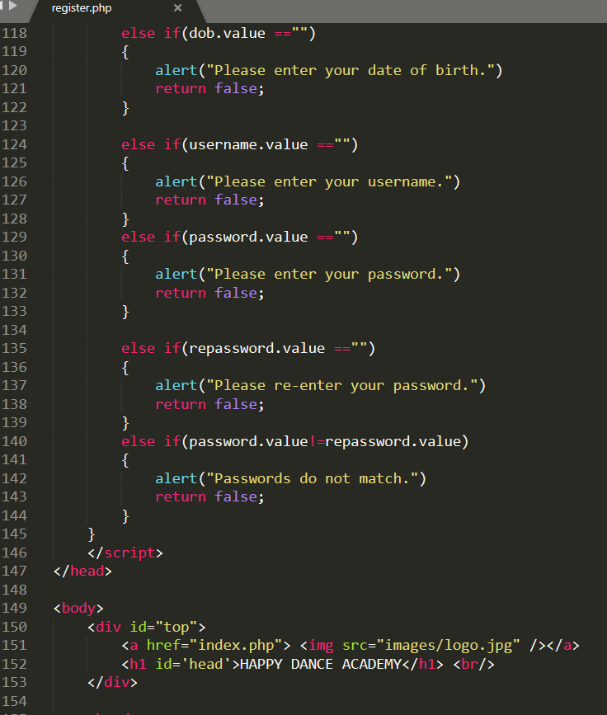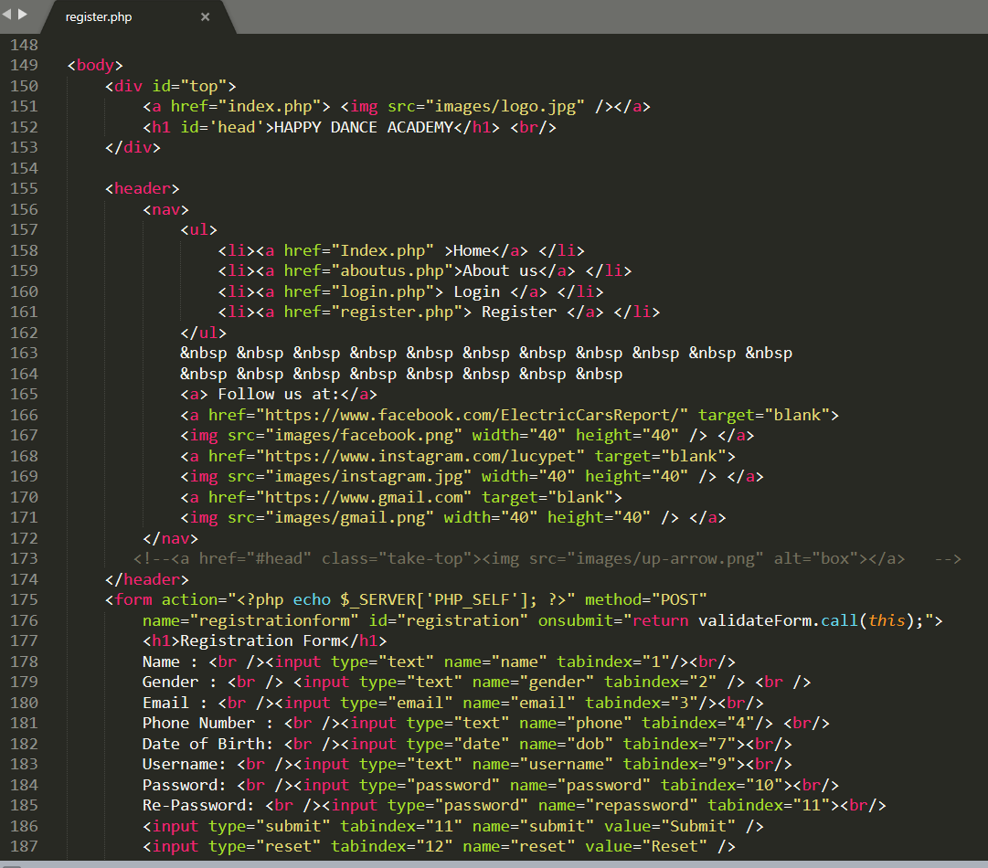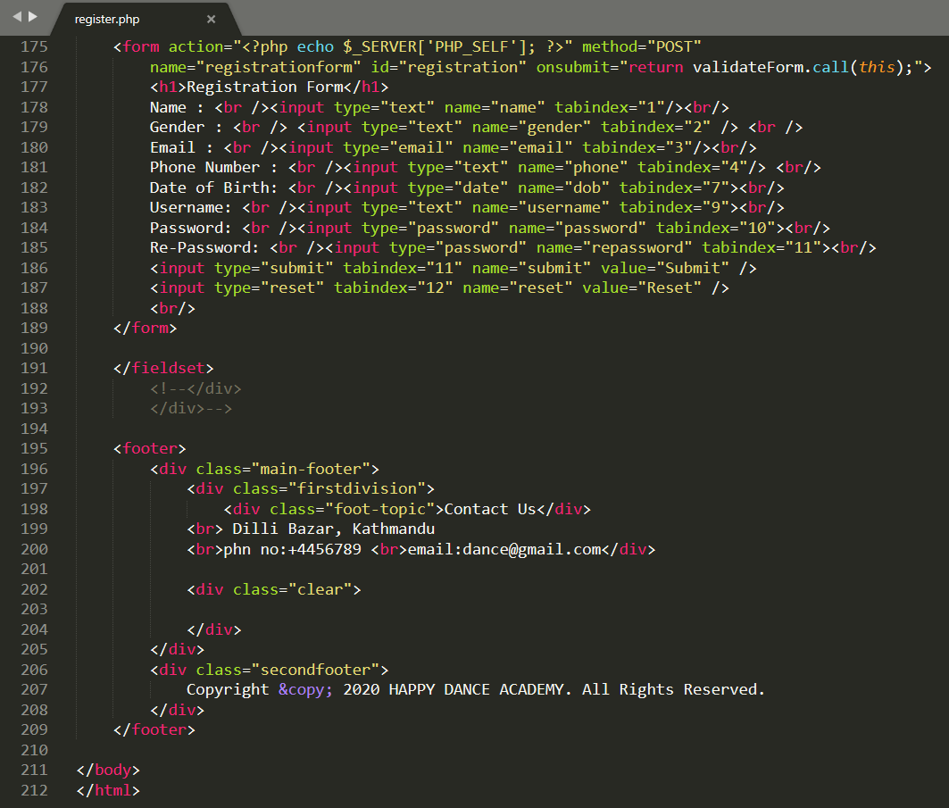

**Uniforms.php**

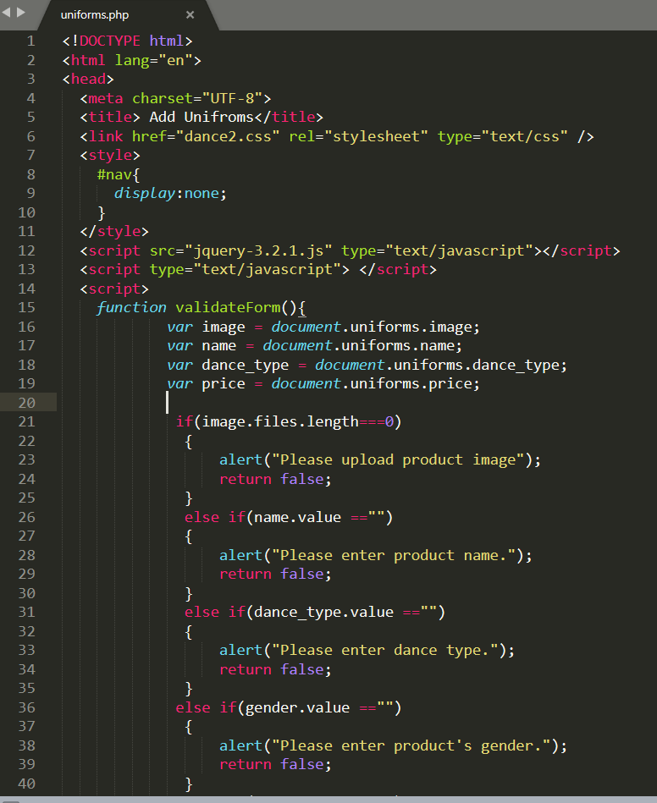

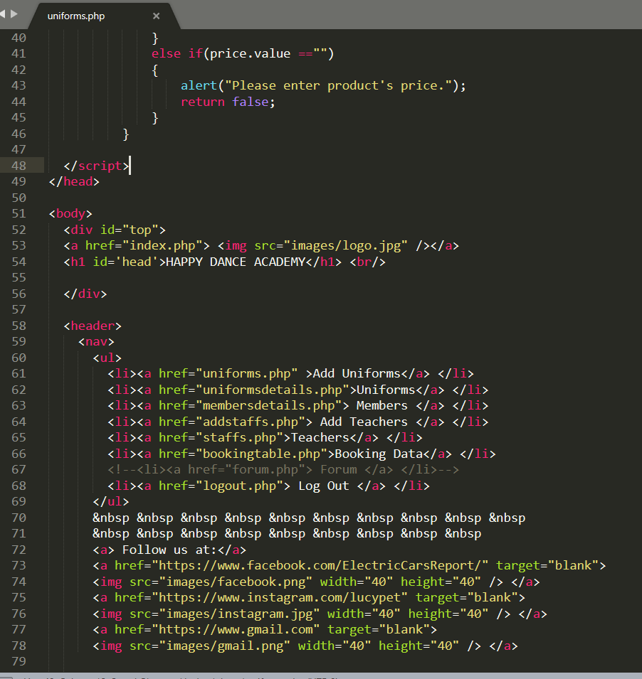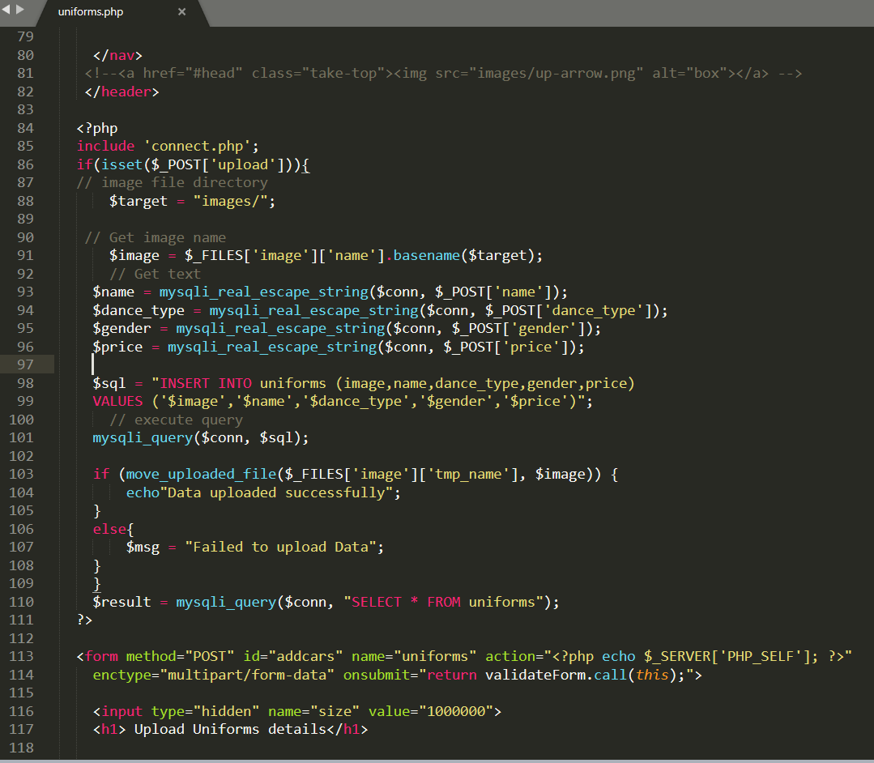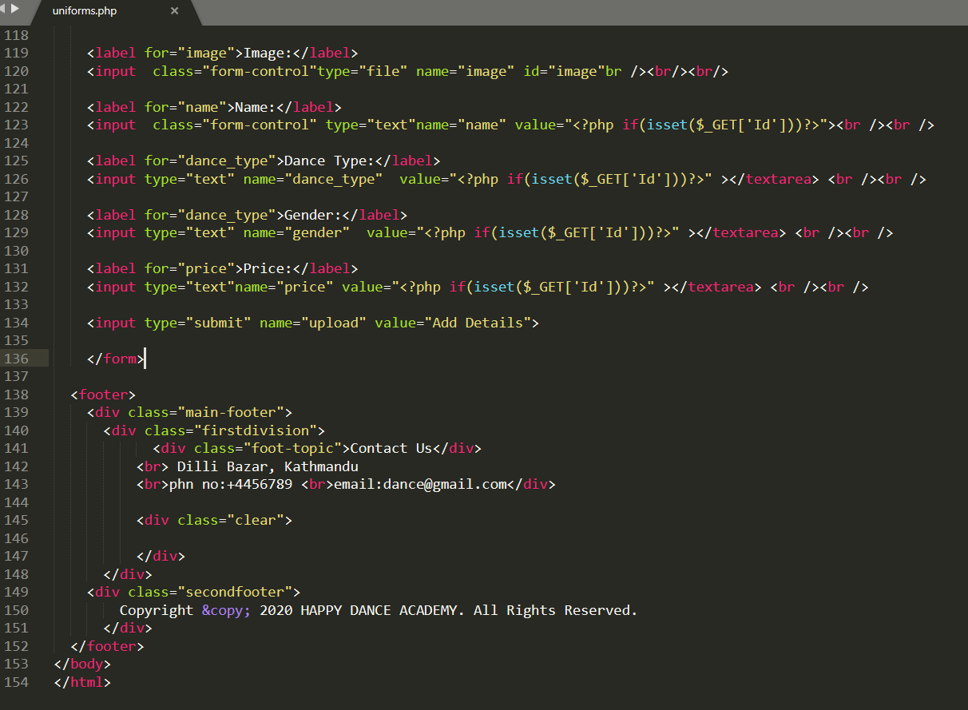

**Uniformsdetails.php**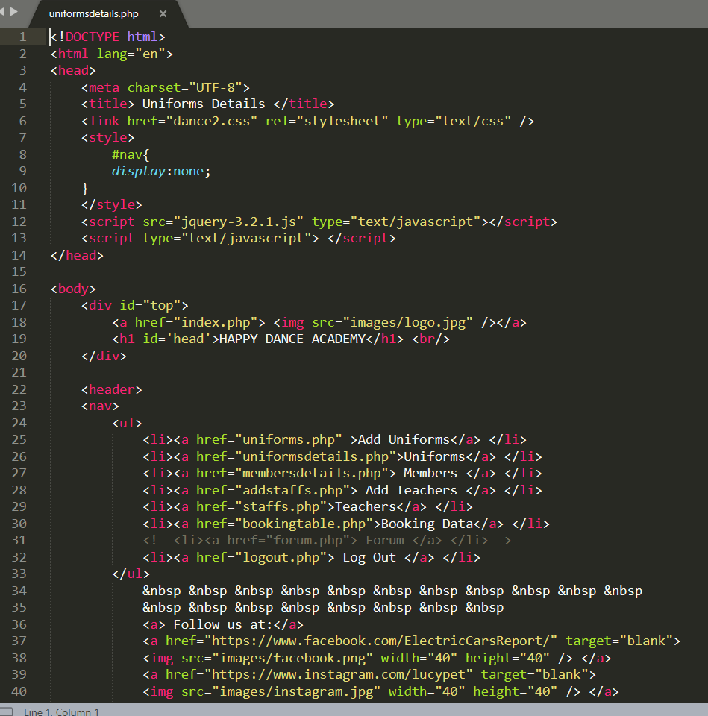

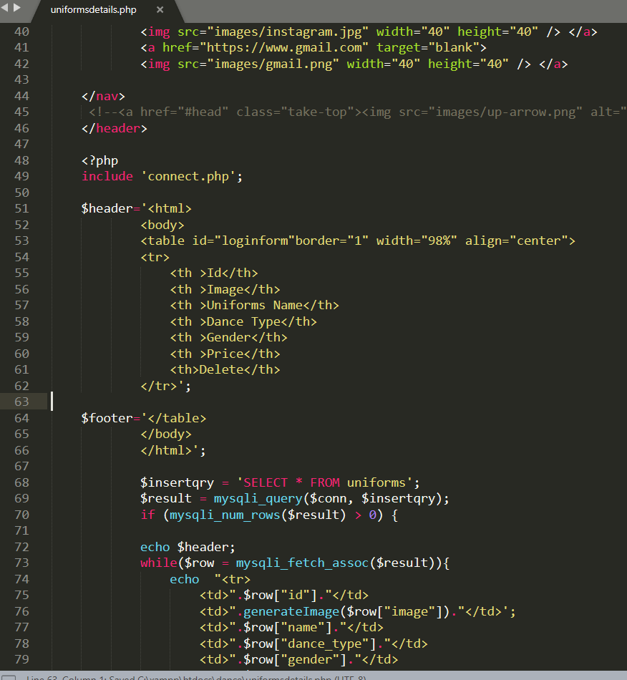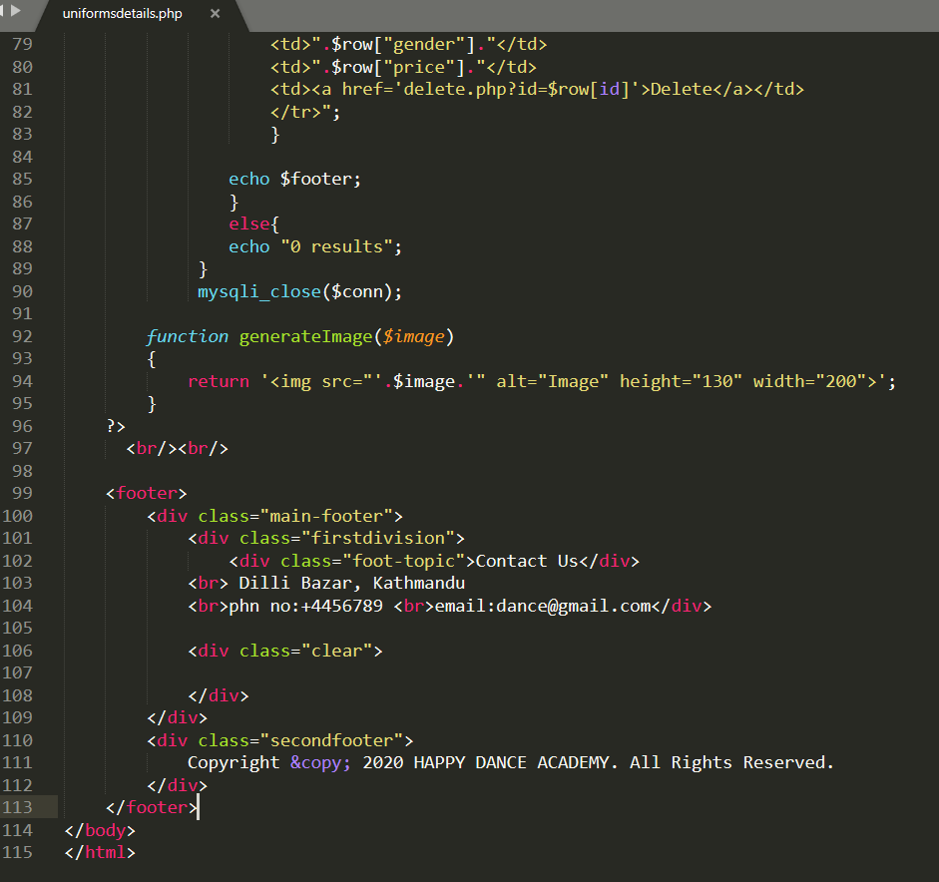

**Membersdetails.php**

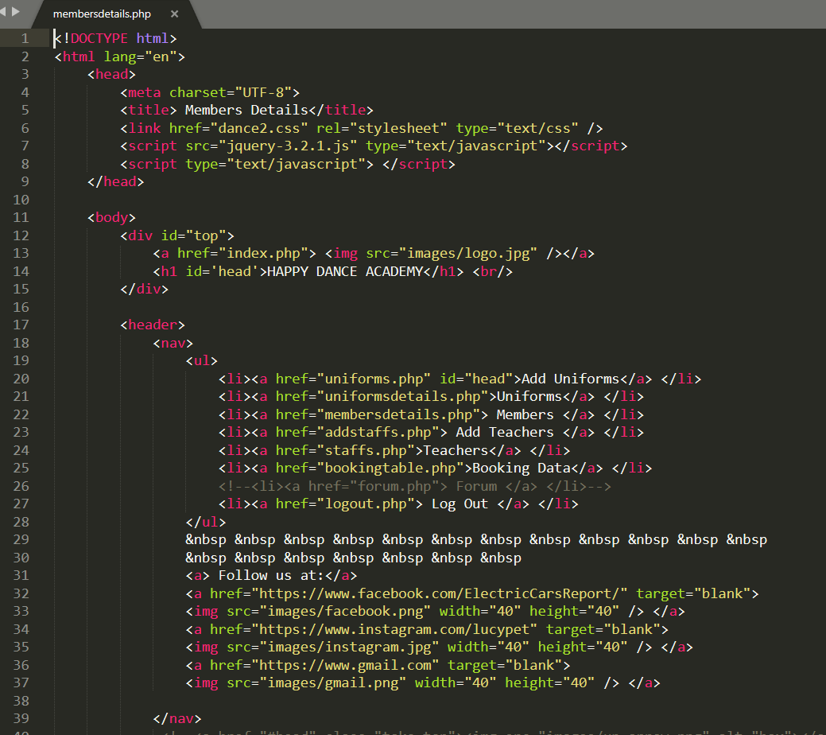

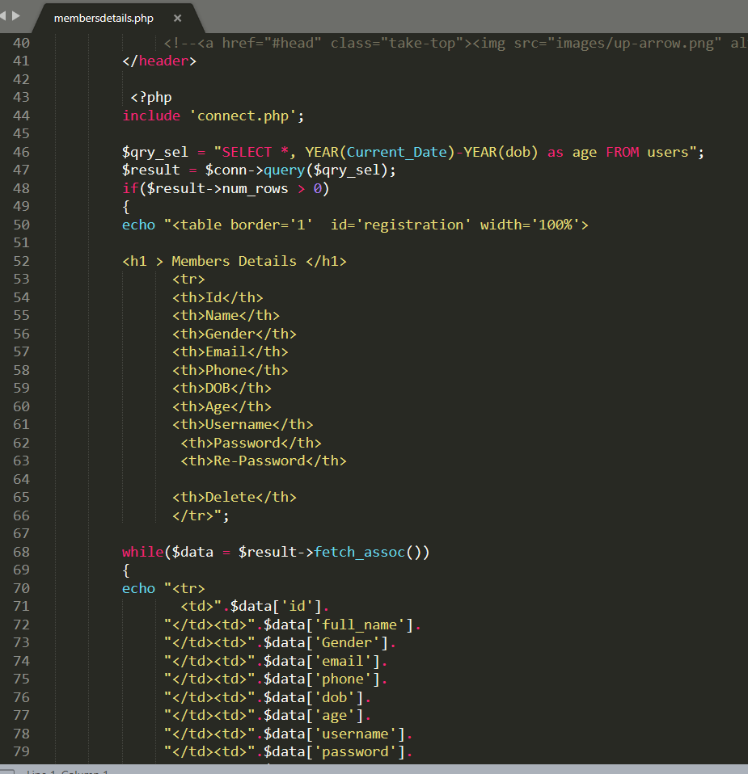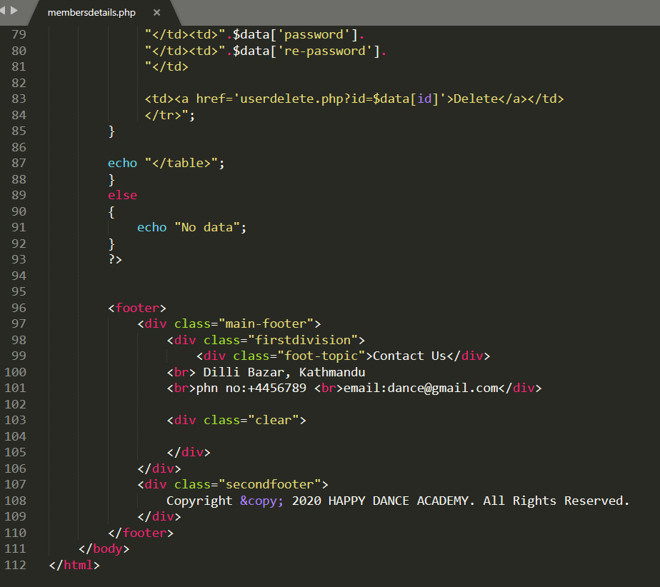

**Addstaffs.php**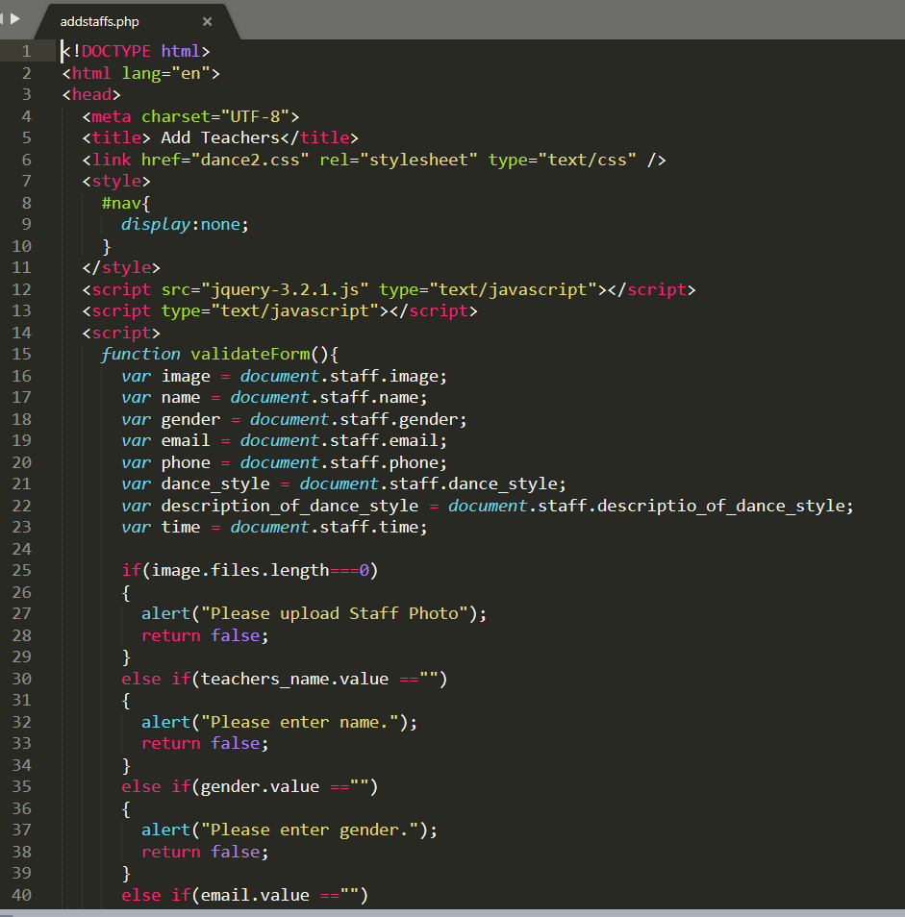

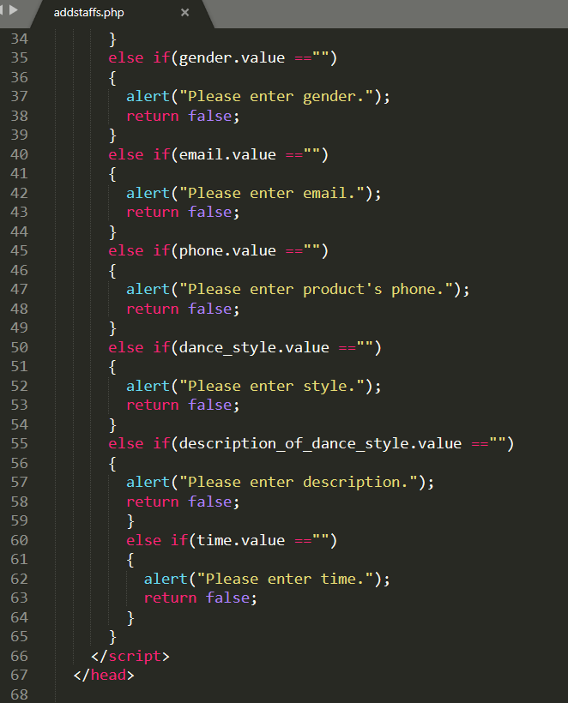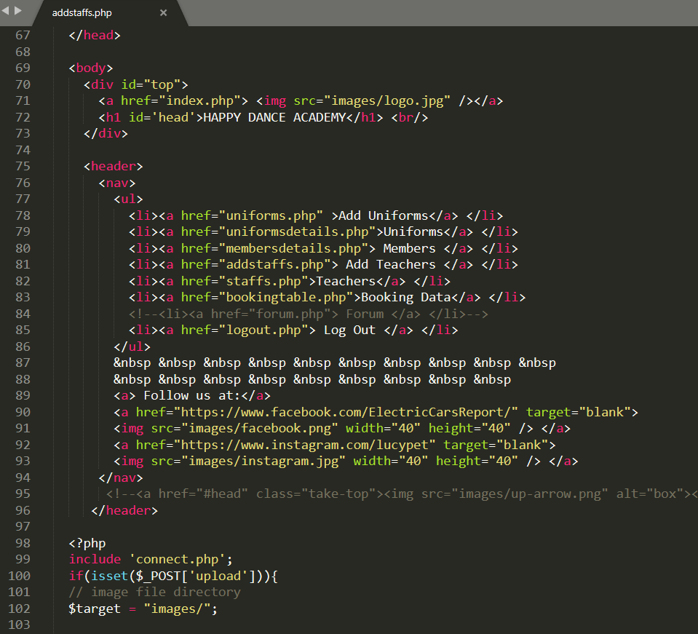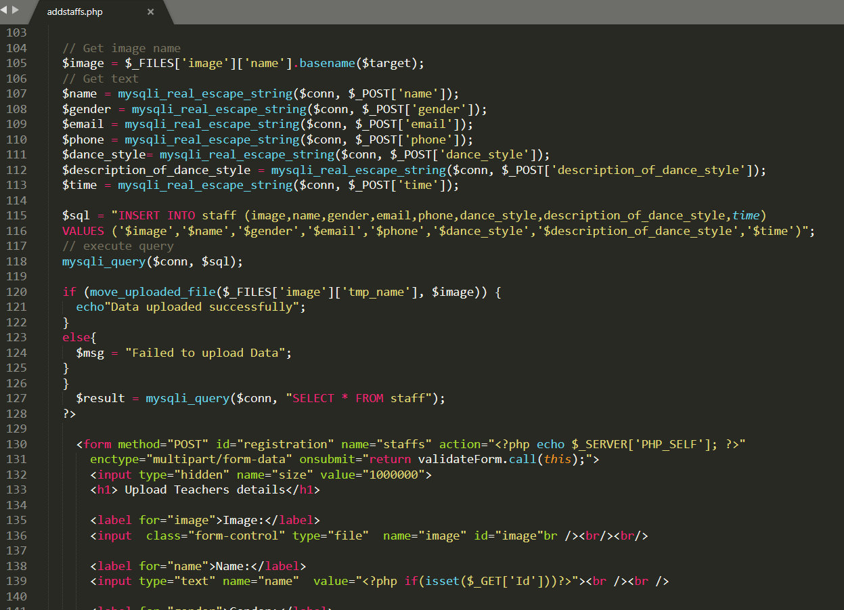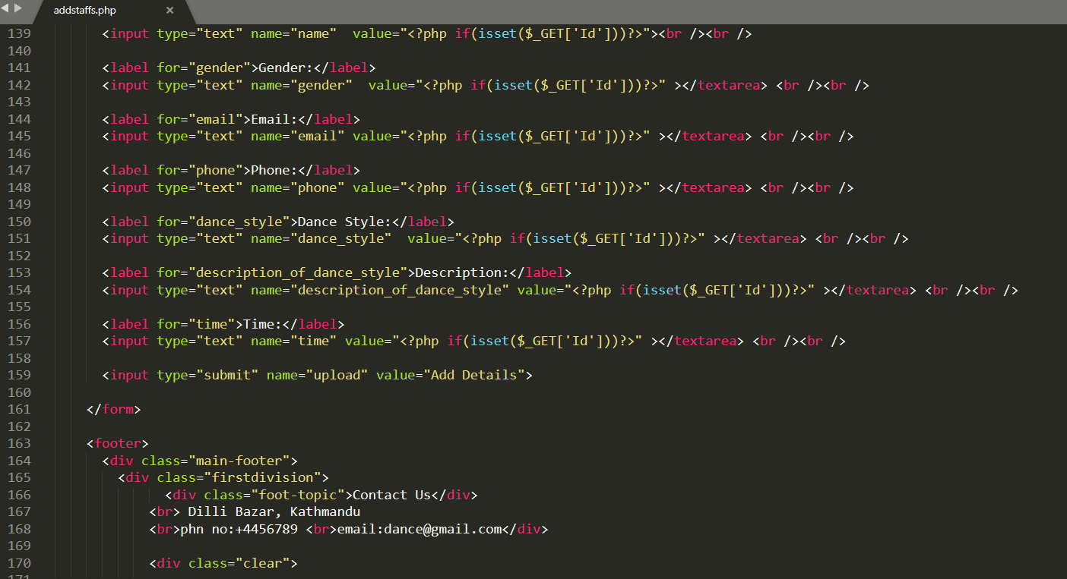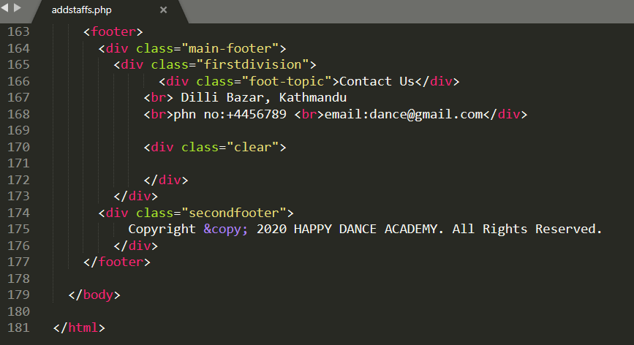

**Staffs.php**

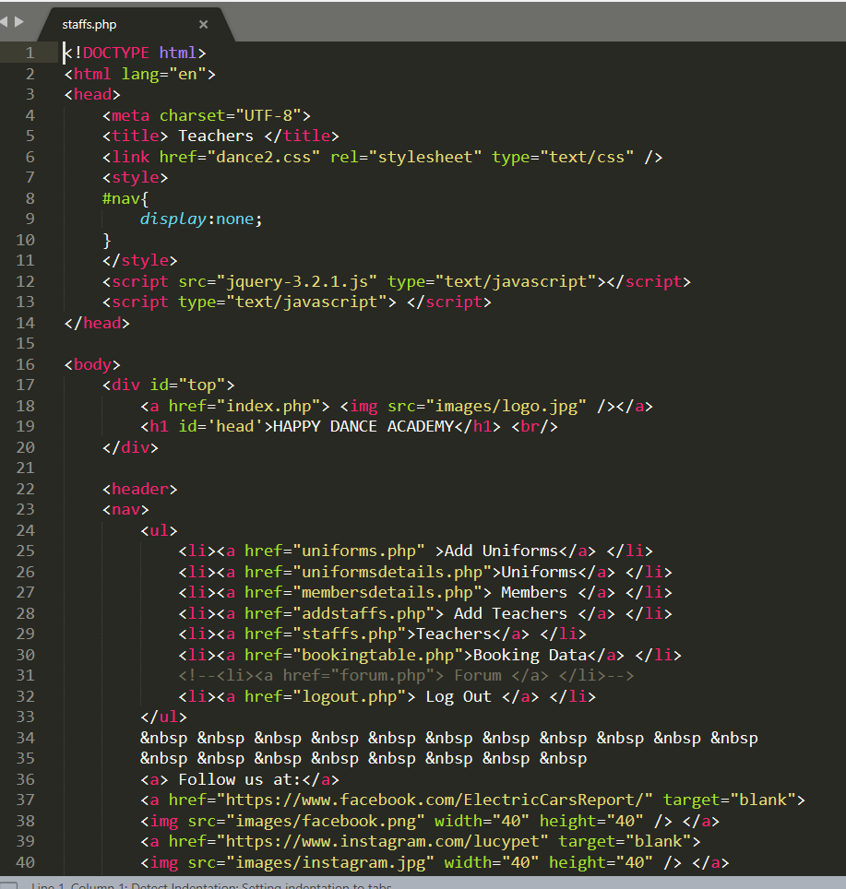

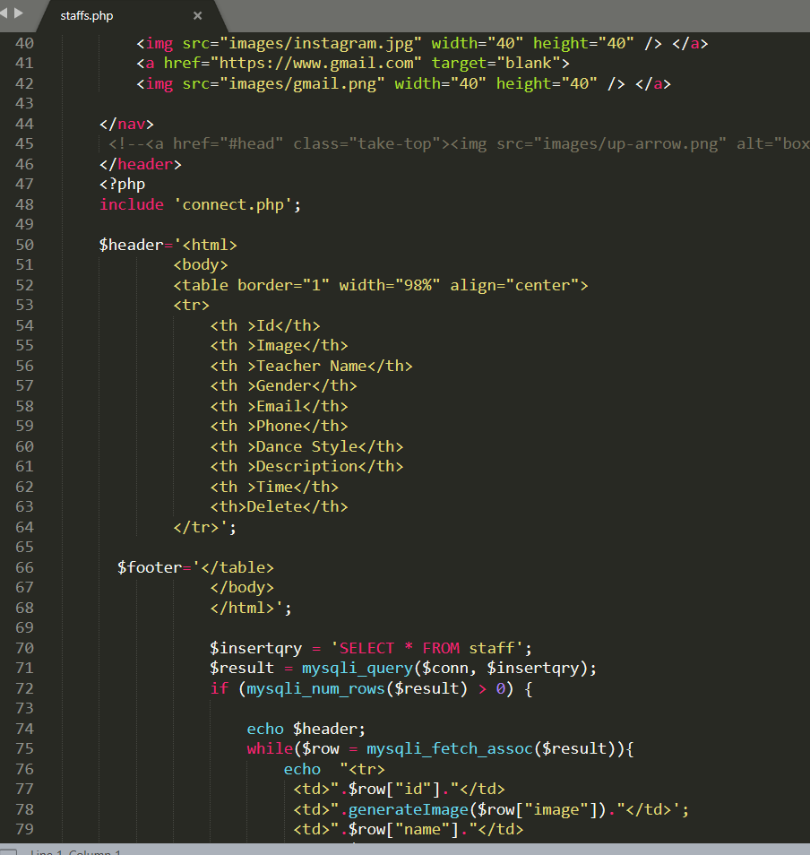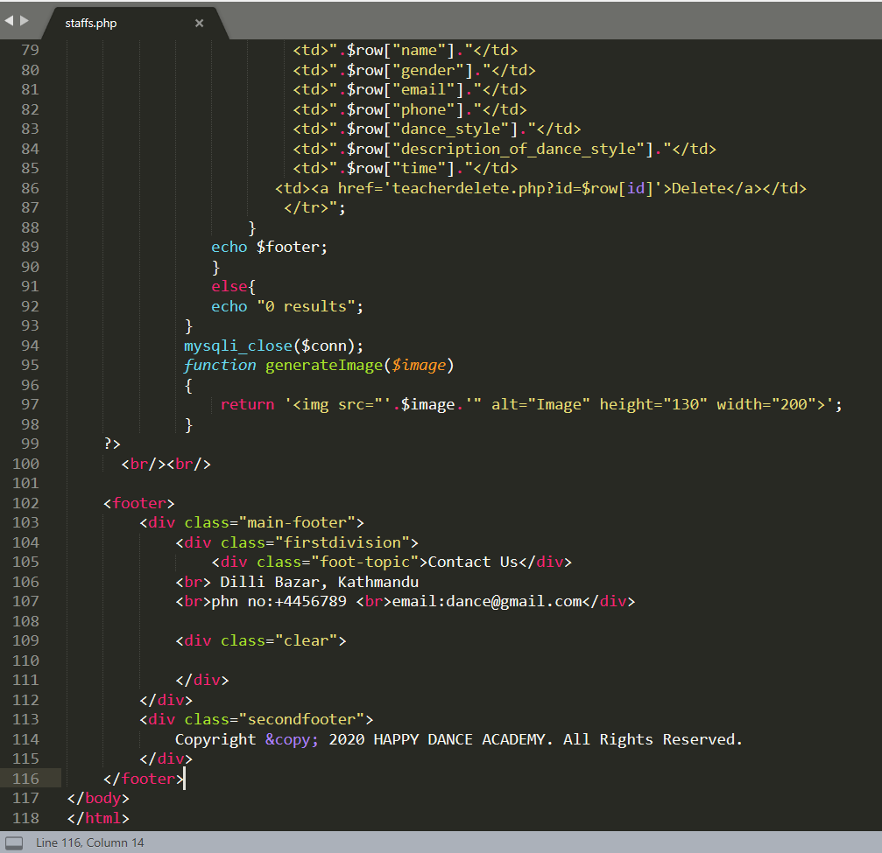

**Bookingtable.php**

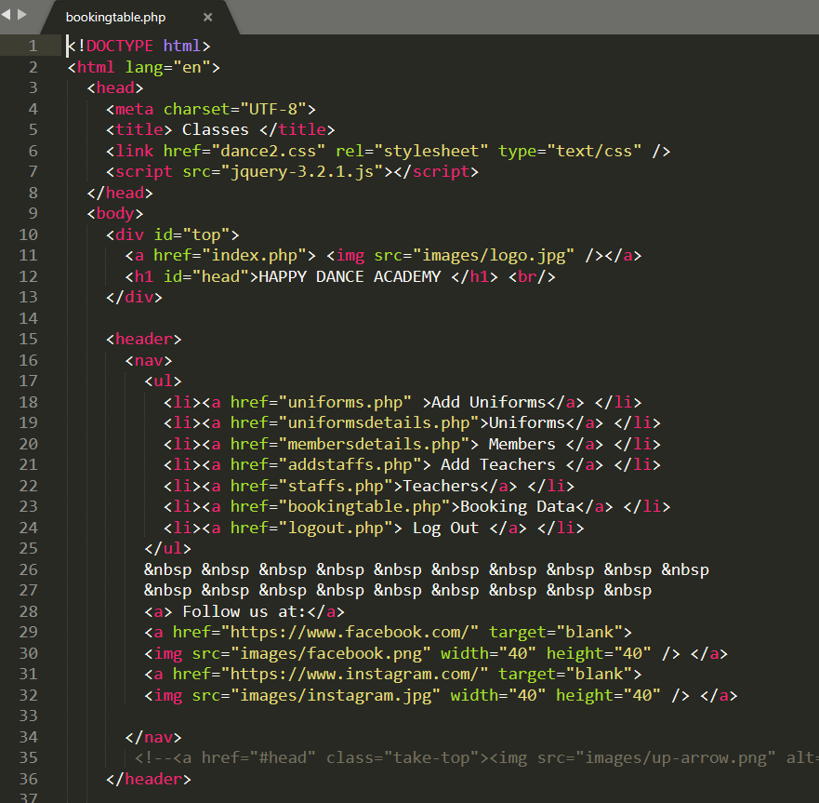

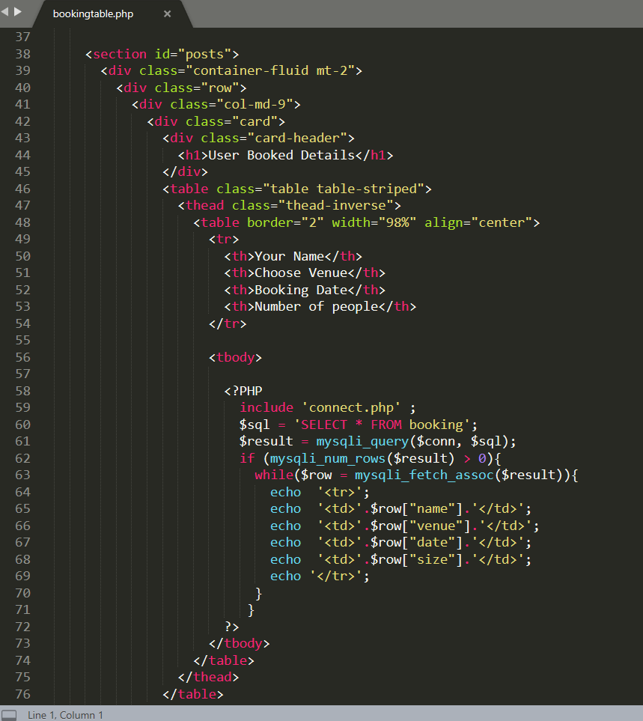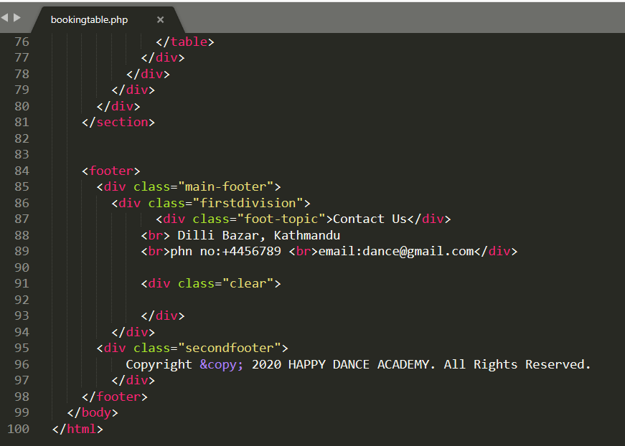

**Logout.php**

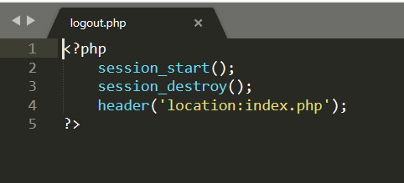

**Connect.php**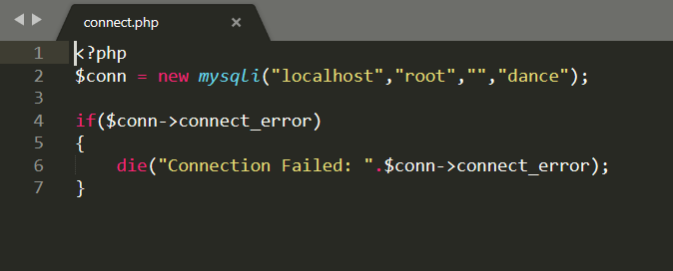

**Uniformdelete.php**

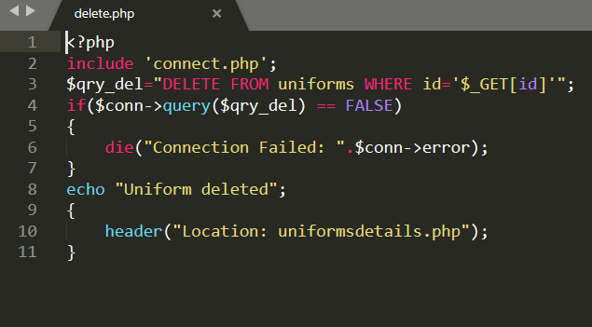

**Userdelete.php**

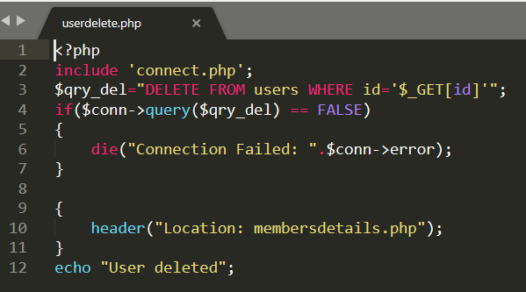

**Teacherdelete.php**

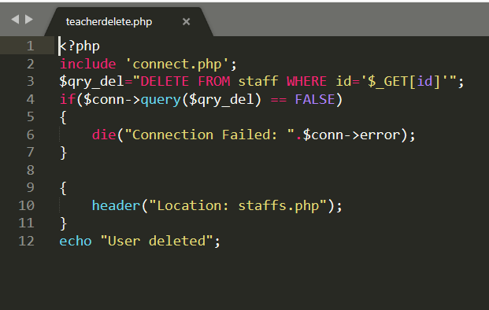

**Memuniforms.php**

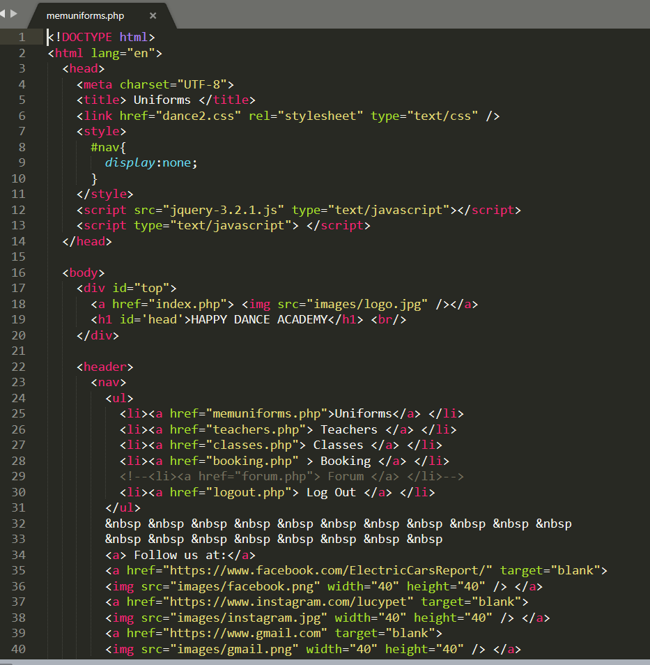

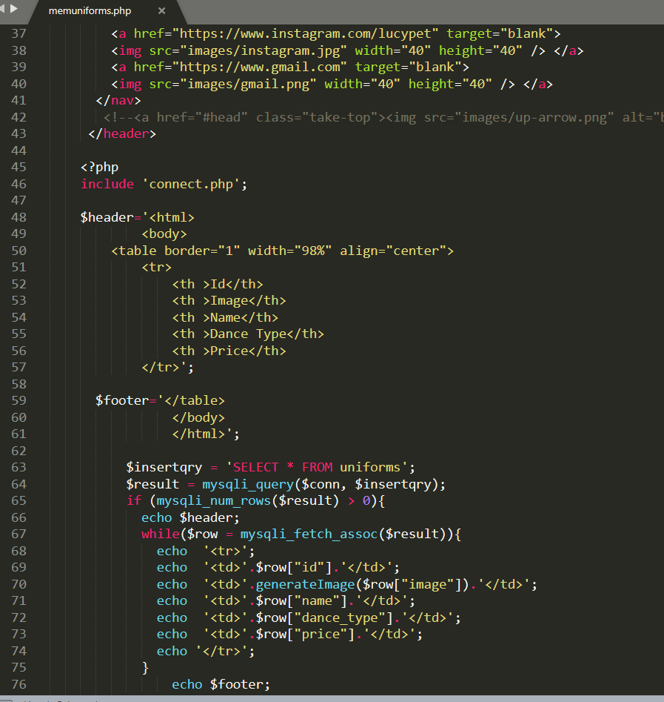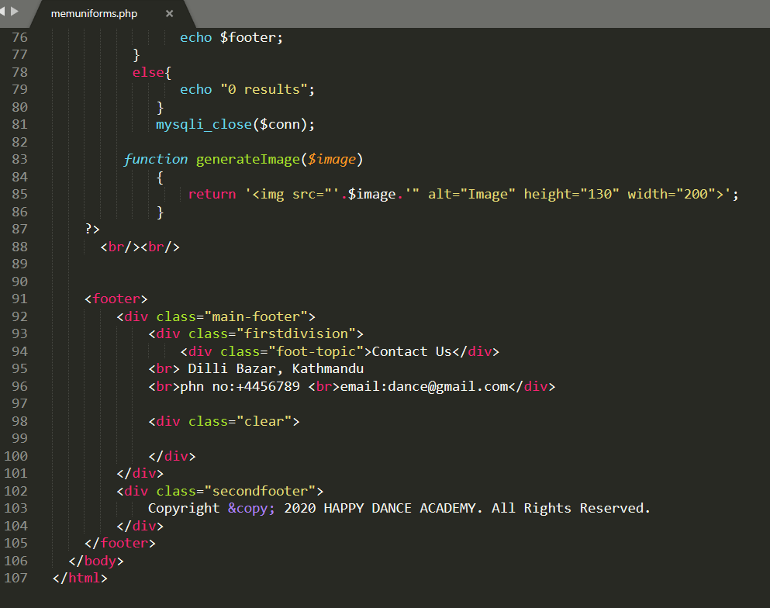

**Teachers.php**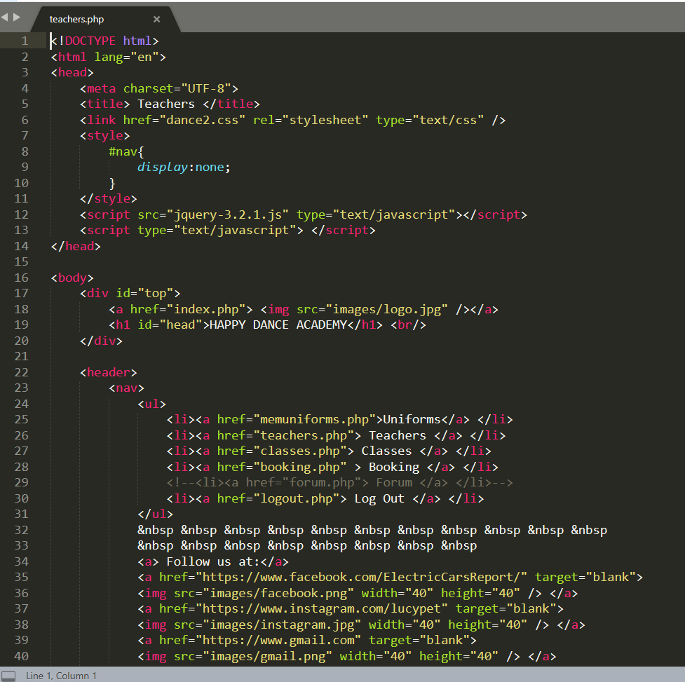

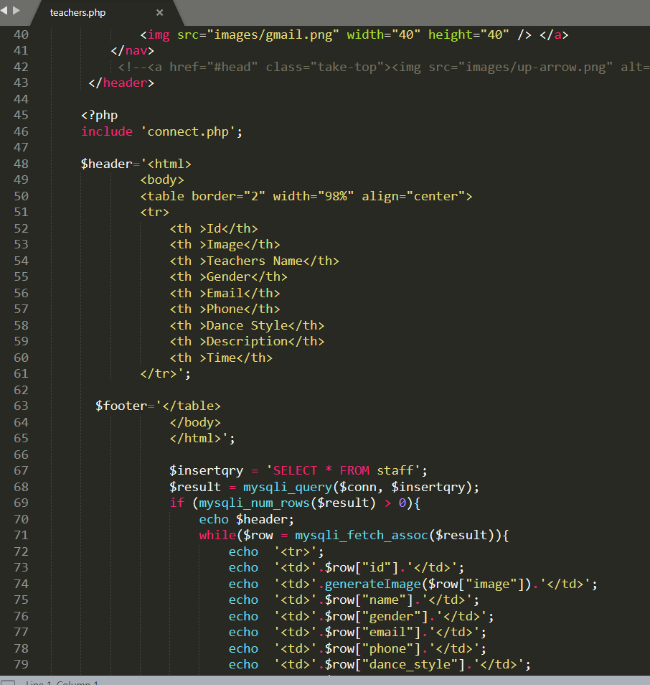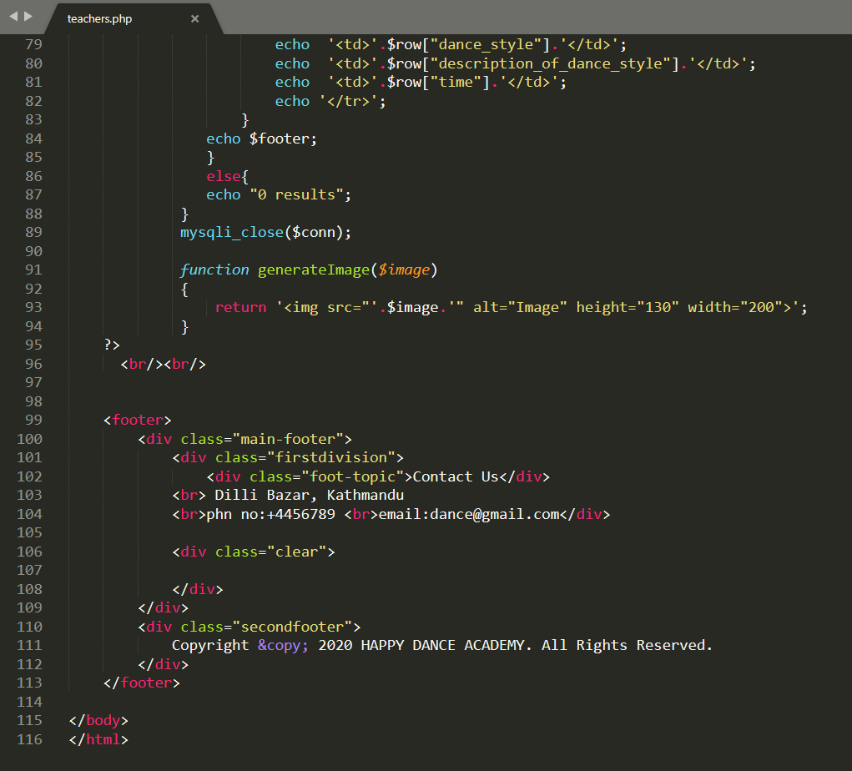

**Classes.php**

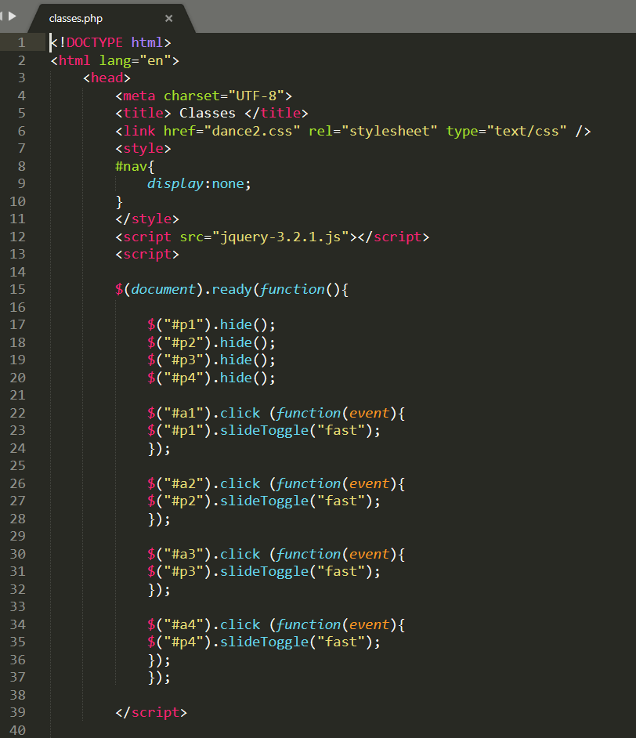

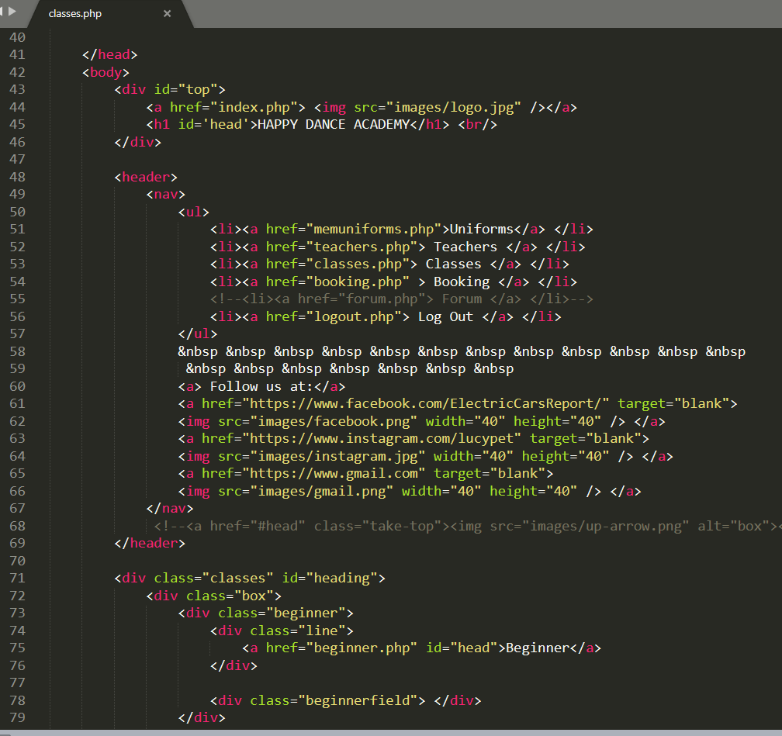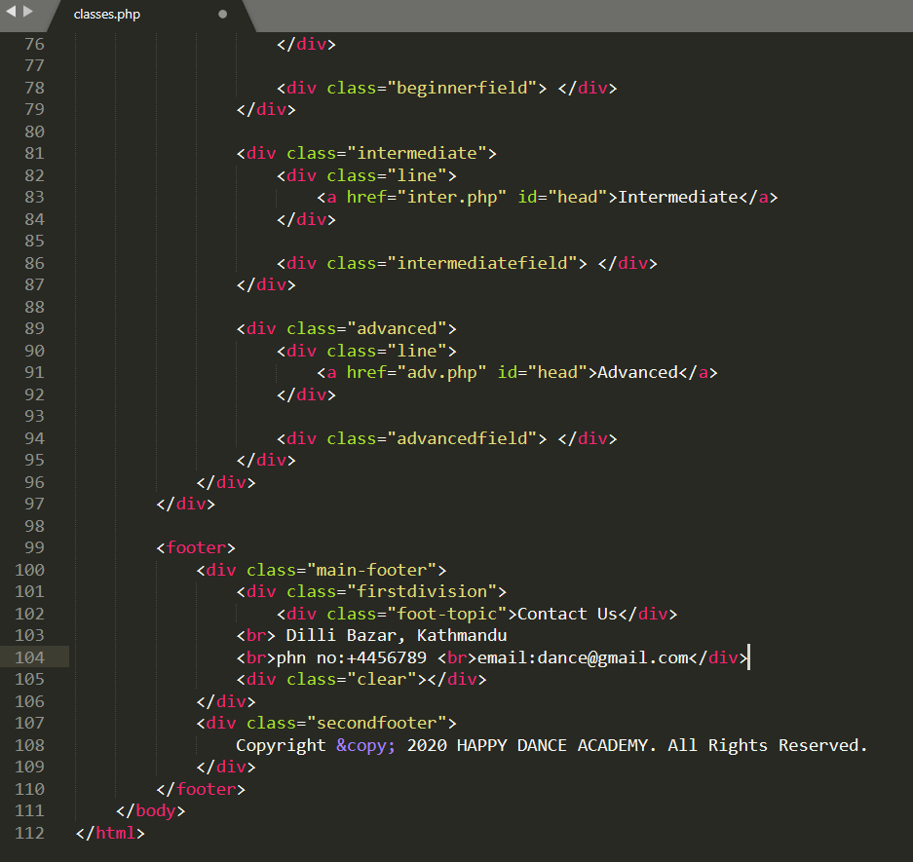

**Beginner.php**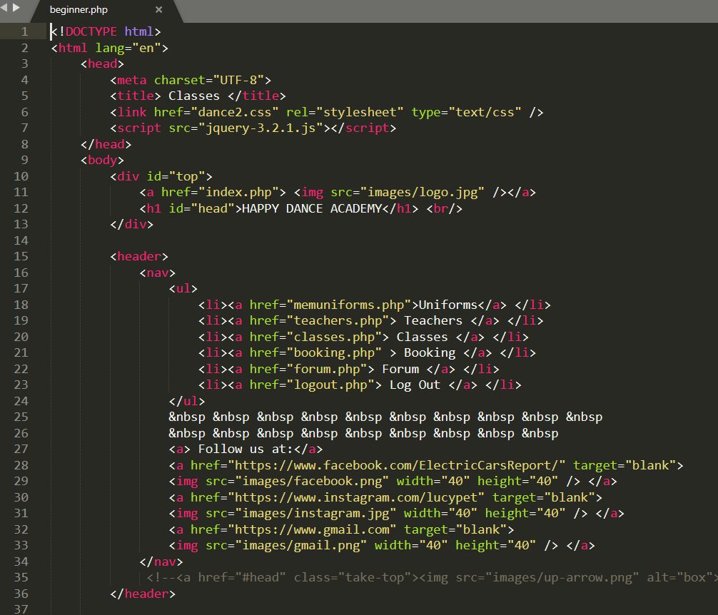

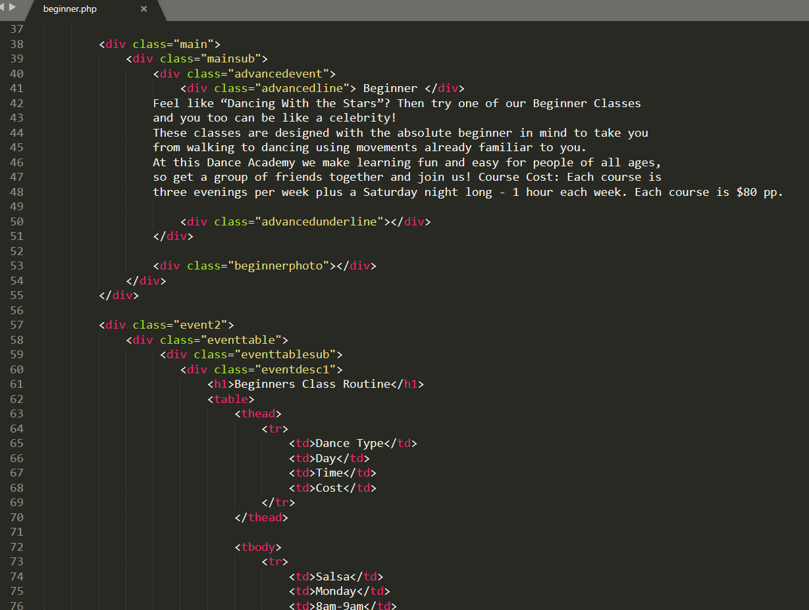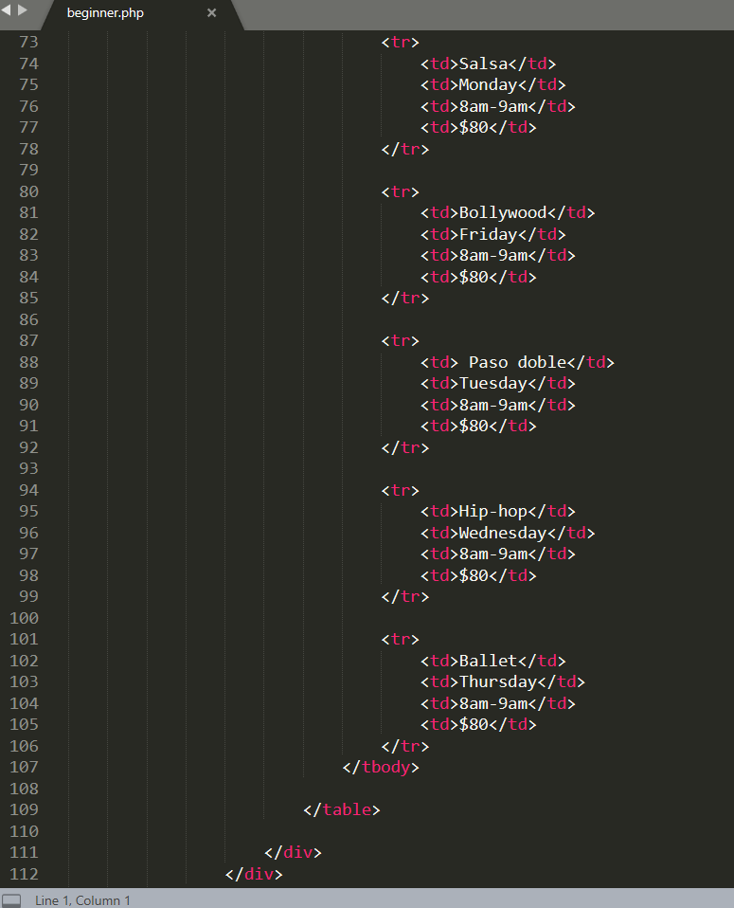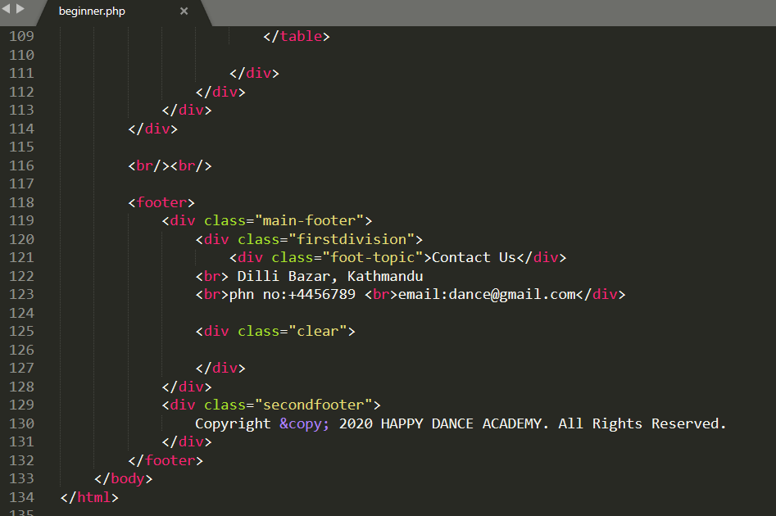

**Inter.php**

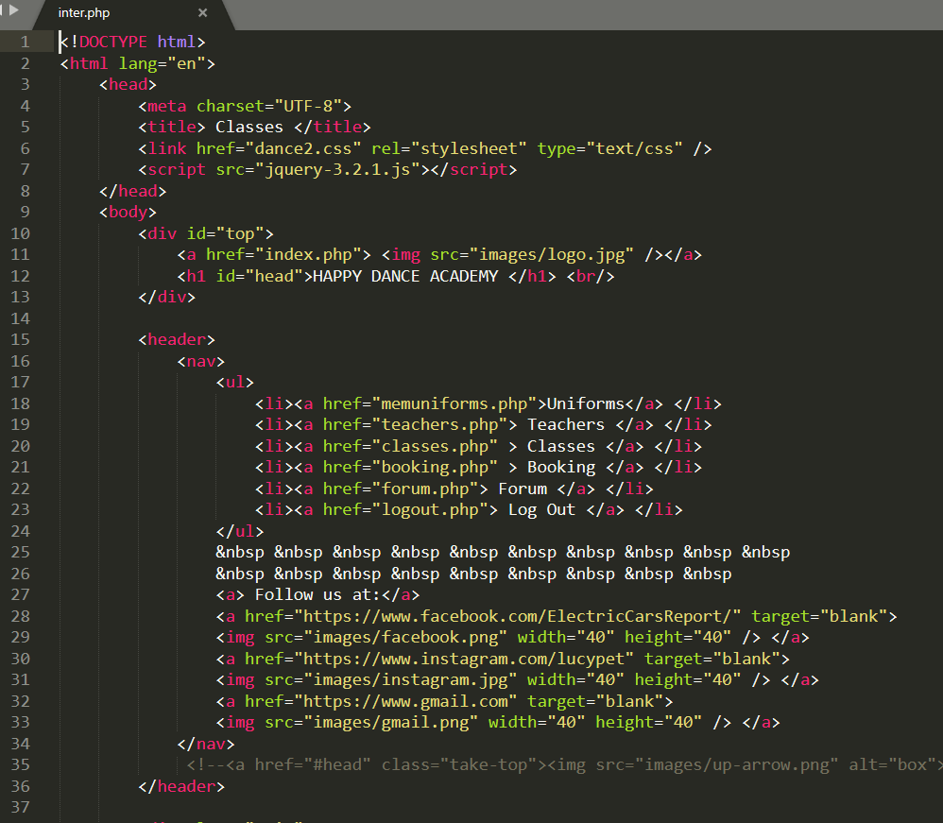

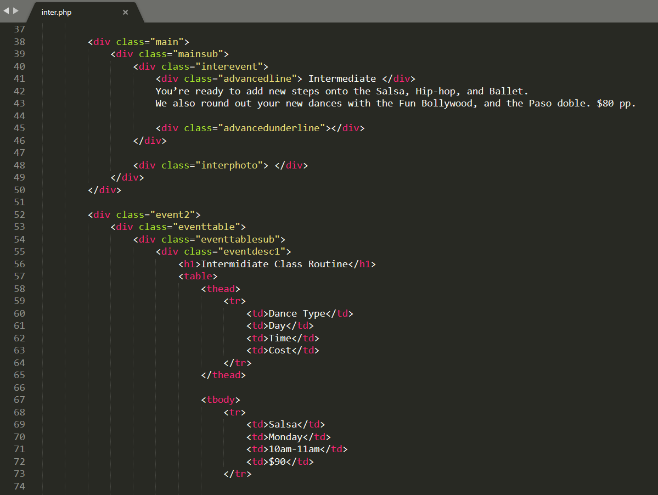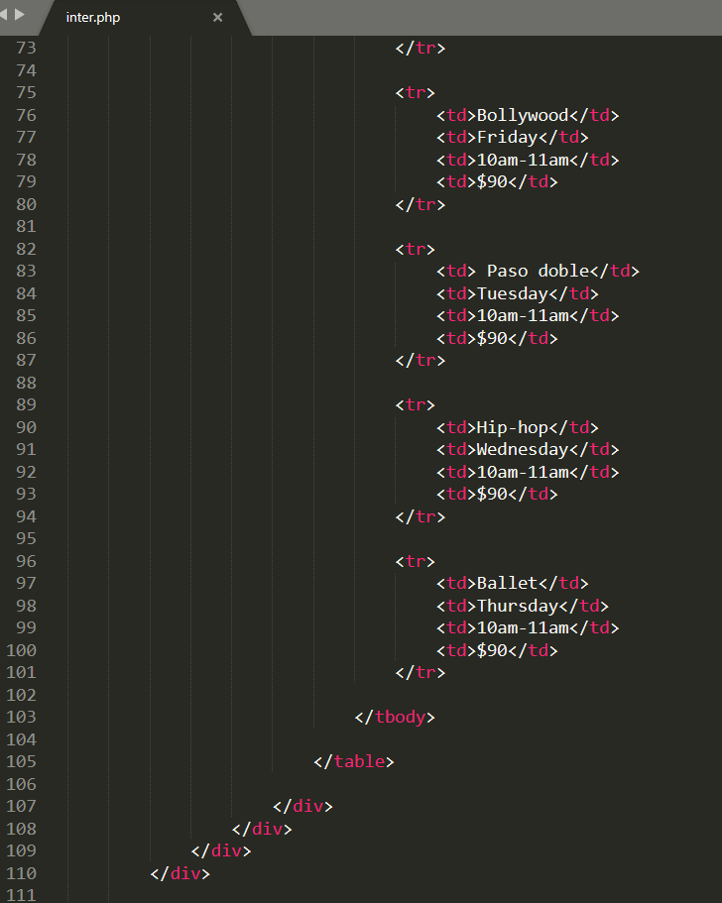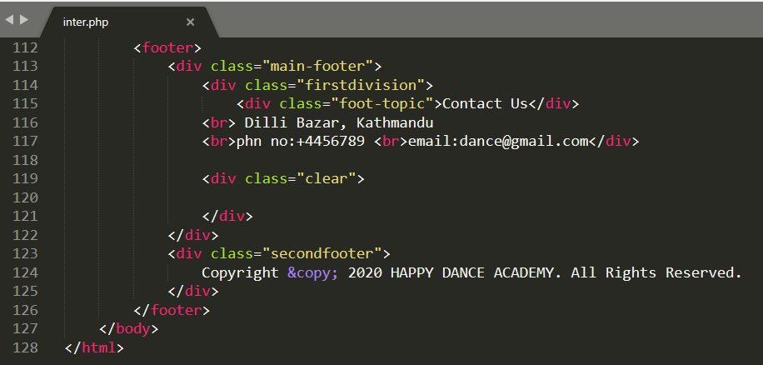

**Adv.php**

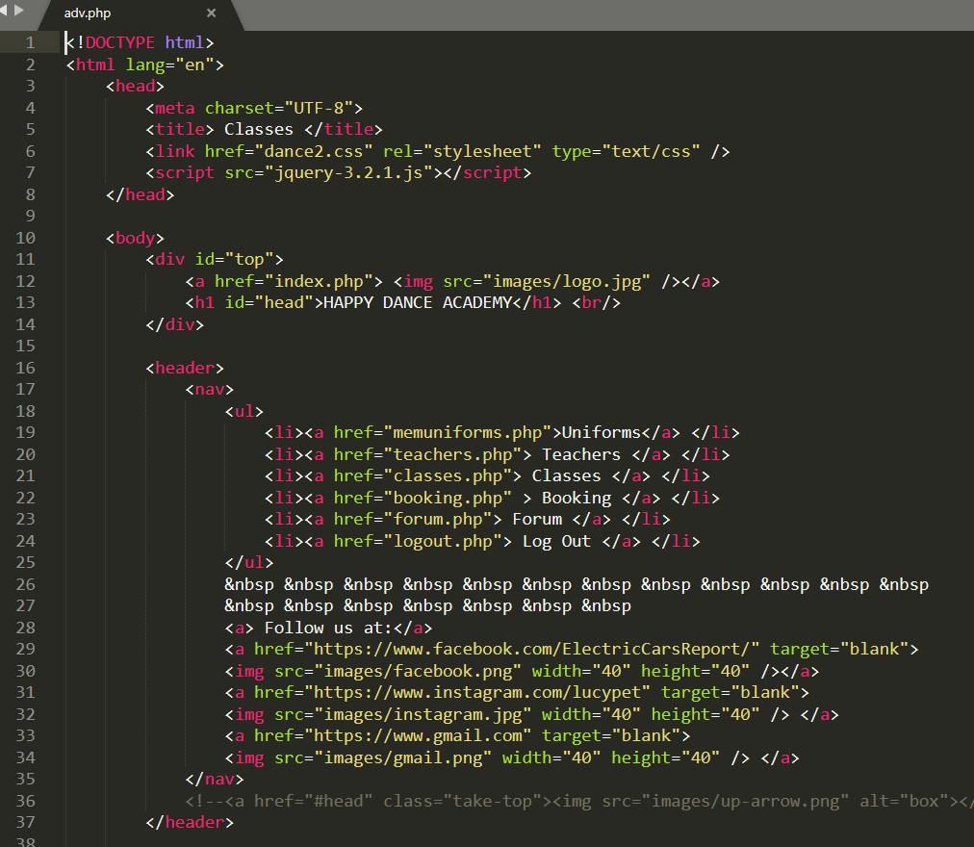

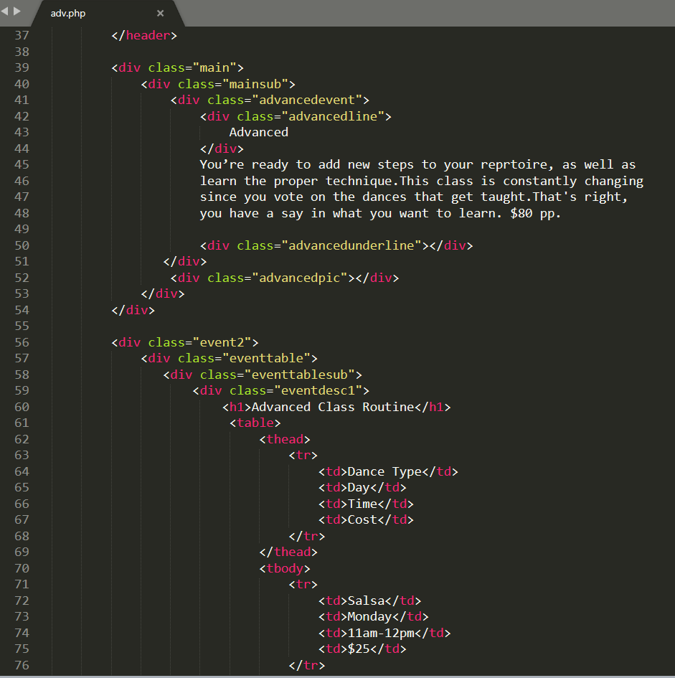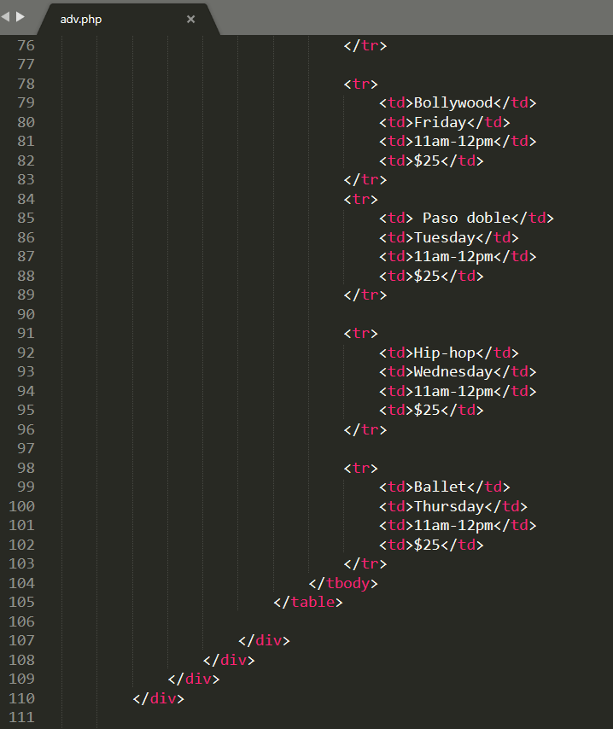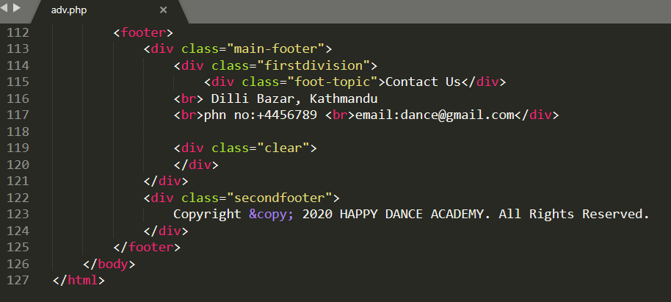

**Booking.php**

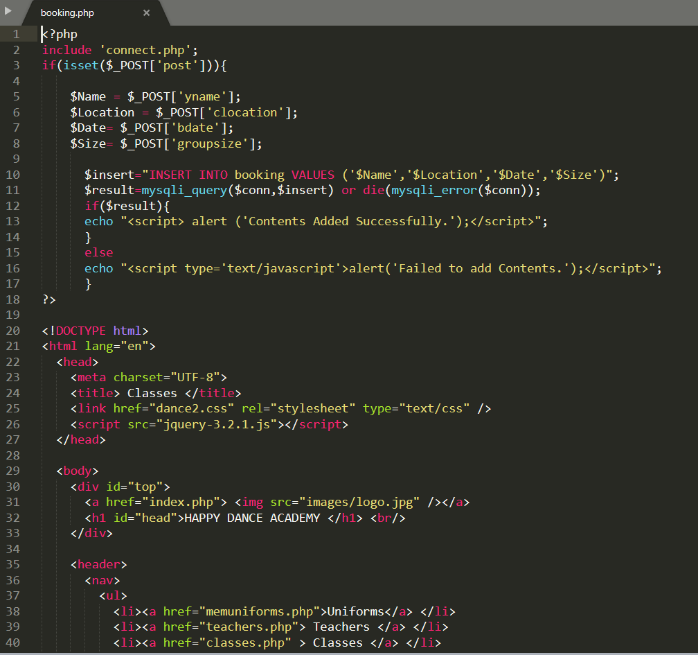

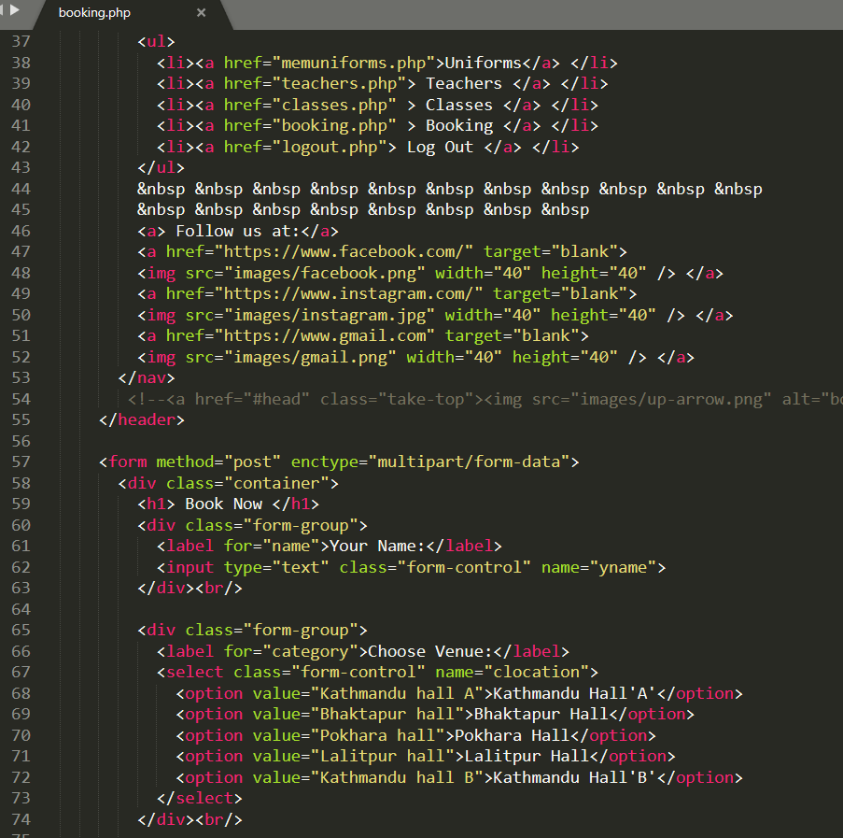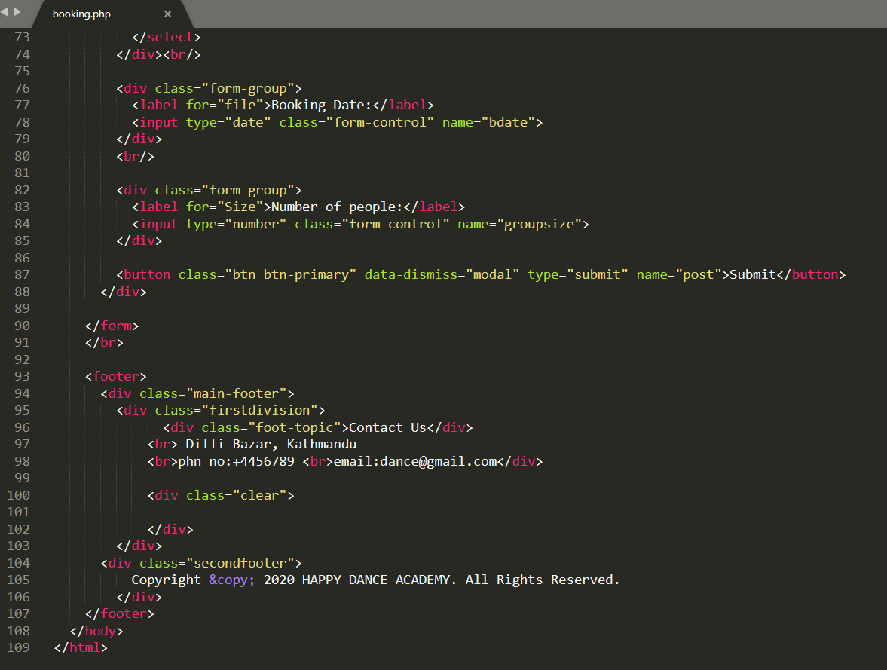

**Dance2.css**

